Module 4 – Introduction to DBMS
Introduction to SQL
Theory Questions:
Questions: 1. What is SQL, and why is it essential in database management?.
SQL (Structured Query Language) is a standard programming language used to create, manage, and manipulate relational databases.
What is SQL?
SQL allows users to:
- Create databases and tables
- Insert, update, delete, and retrieve data
- Control access to data
- Maintain data integrity
It works with relational database systems such as MySQL, PostgreSQL, Oracle, and SQL Server.
Why is SQL essential in database management?
- Data Retrieval
  - SQL makes it easy to retrieve specific data using queries like SELECT
.
- Data Manipulation
  - It allows inserting (INSERT), updating (UPDATE), and deleting (DELETE) records efficiently.

3.Database Structure Management
  - SQL is used to create and modify database objects such as tables, views, indexes, and schemas.

4.Data Integrity and Accuracy
  - Constraints (PRIMARY KEY, FOREIGN KEY, UNIQUE, NOT NULL) ensure data consistency and reliability.
5.Security and Access Control
  - SQL manages user permissions using GRANT and REVOKE.
6. Standardized Language
  - SQL is an international standard, so skills are transferable across different database systems.
7.Efficient Handling of Large Data
  - SQL can process large volumes of data quickly and efficiently.

2. Explain the difference between DBMS and RDBMS.
Aspect | DBMS (Database Management System) | RDBMS (Relational Database Management System)
Definition | Software that manages databases and allows data storage, retrieval, and manipulation | A type of DBMS based on the relational model, where data is stored in tables
Data Structure | Stores data as files or hierarchical structures | Stores data in tables (rows and columns)
Relationships | Does not support relationships between data | Supports relationships using primary keys and foreign keys
Normalization | Does not support normalization | Supports normalization to reduce data redundancy
Data Integrity | Limited data integrity | Strong data integrity using constraints
Scalability | Suitable for small applications | Suitable for large, complex applications
Examples | File system, XML databases | MySQL, PostgreSQL, Oracle, SQL Server
Security | Basic security features | Advanced security and access control

3. Describe the role of SQL in managing relational databases.
Role of SQL in simple English:
- Create databases and tables
SQL is used to define the structure of databases and tables.
- Insert, update, and delete data
SQL commands help manage data stored in tables.
- Retrieve data
SQL allows users to fetch required data using SELECT queries.
- Manage relationships
SQL maintains relationships between tables using primary keys and foreign keys.
- Ensure data integrity
Constraints ensure data is accurate and consistent.
- Control security and access
SQL manages user permissions and protects data.
4. What are the key features of SQL?
The key features of SQL (Structured Query Language) are:
- Easy to use
SQL uses simple and readable commands.
- Data retrieval
Allows fast and efficient data fetching using SELECT.
- Data manipulation
Supports inserting, updating, and deleting data (INSERT, UPDATE, DELETE).
- Database structure management
Used to create and modify databases and tables (CREATE, ALTER, DROP).
- Data integrity
Ensures accuracy using constraints like PRIMARY KEY, FOREIGN KEY, UNIQUE, and NOT NULL.
- Security and access control
Manages user permissions with GRANT and REVOKE.
- Standard language
Works across many database systems like MySQL, Oracle, and SQL Server.
- Scalable and efficient
Handles large amounts of data effectively.

LAB EXERCISES:
• Lab 1: Create a new database named school_db and a table called students with the following columns: student_id, student_name, age, class, and address.
Step 1: Create a new database
CREATE DATABASE schooldboct
-- Step 2: Use the new database
USE schooldboct;
-- Step 3: Create the students table
CREATE TABLE students (student_id INT PRIMARY KEY AUTO_INCREMENT, student_name VARCHAR(100) , age INT, class VARCHAR(50), address VARCHAR(255));

• Lab 2: Insert five records into the students table and retrieve all records using the SELECT statement.
INSERT INTO students (student_name, age, class, address)
VALUES
('Alice Johnson', 14, '8th Grade', '123 Maple Street'),
('Brian Smith', 15, '9th Grade', '456 Oak Avenue'),
('Catherine Lee', 13, '7th Grade', '789 Pine Road'),
('David Brown', 16, '10th Grade', '321 Cedar Lane'),
('Emma Wilson', 14, '8th Grade', '654 Birch Boulevard');

Output:
student_id | student_name | age | class | address
1 | Alice Johnson | 14 | 8th Grade | 123 Maple Street
2 | Brian Smith | 15 | 9th Grade | 456 Oak Avenue
3 | Catherine Lee | 13 | 7th Grade | 789 Pine Road
4 | David Brown | 16 | 10th Grade | 321 Cedar Lane
5 | Emma Wilson | 14 | 8th Grade | 654 Birch Boulevard

2. SQL Syntax Theory Questions:
1. What are the basic components of SQL syntax?
SQL syntax consists of different parts or components that are used to perform operations on a database. The main components are:
- Keywords
  - Reserved words that SQL recognizes and uses to perform operations.
  - Examples: SELECT, INSERT, UPDATE, DELETE, CREATE, DROP.
- Identifiers
  - Names given to database objects like tables, columns, and databases.
  - Examples: students (table name), student_name (column name).
- Expressions
  - Combinations of symbols, column names, and values that produce a result.
  - Example: age + 1, 'Alice' || ' Johnson' (concatenation).
- Clauses
  - Part of SQL statements that perform specific functions.
  - Examples: WHERE, FROM, GROUP BY, ORDER BY.
- Predicates
  - Conditions used to filter data in queries.
  - Examples: =, >, <, LIKE, BETWEEN, IN.
- Operators
  - Symbols that perform operations on data.
  - Examples: +, -, *, /, AND, OR, NOT.
- Statements / Commands
  - Complete instructions executed by the database.
  - Examples:
    - SELECT * FROM students;
    - INSERT INTO students VALUES (...);

2. Write the general structure of an SQL SELECT statement.
SELECT column1, column2, ...
FROM table_name
WHERE condition
GROUP BY column_name
HAVING condition
ORDER BY column_name ASC|DESC;
Explanation of each part:
- SELECT column1, column2, ...
  - Specifies the columns you want to retrieve.
  - Use * to select all columns.
- FROM table_name
  - Specifies the table from which to retrieve the data.
- WHERE condition (optional)
  - Filters the rows based on a condition.
  - Example: WHERE age > 14
- GROUP BY column_name (optional)
  - Groups rows that have the same values in a column.
  - Often used with aggregate functions like COUNT, SUM.
- HAVING condition (optional)
  - Filters groups after aggregation.
  - Example: HAVING COUNT(student_id) > 2
- ORDER BY column_name ASC|DESC (optional)
  - Sorts the result in ascending (ASC) or descending (DESC) order.

3. Explain the role of clauses in SQL statements
Key Roles of Clauses:
- SELECT clause
  - Specifies which columns to retrieve from the table.
  - Example: SELECT student_name, age
- FROM clause
  - Specifies the table(s) to get data from.
  - Example: FROM students
- WHERE clause
  - Filters rows based on a condition.
  - Example: WHERE age > 14
- GROUP BY clause
  - Groups rows with the same values in one or more columns.
  - Example: GROUP BY class
- HAVING clause
  - Filters groups after aggregation (used with GROUP BY).
  - Example: HAVING COUNT(student_id) > 2
- ORDER BY clause
  - Sorts the result ascending (ASC) or descending (DESC).
  - Example: ORDER BY age DESC

LAB EXERCISES:
• Lab 1: Write SQL queries to retrieve specific columns (student_name and age) from the students table.
SELECT student_name, age
FROM students;
student_name | age
Alice Johnson | 14
Brian Smith | 15
Catherine Lee | 13
David Brown | 16
Emma Wilson | 14

• Lab 2: Write SQL queries to retrieve all students whose age is greater than 10.
SELECT * FROM students ,WHERE age > 10;
student_id | student_name | age | class | address
1 | Alice Johnson | 14 | 8th Grade | 123 Maple Street
2 | Brian Smith | 15 | 9th Grade | 456 Oak Avenue
3 | Catherine Lee | 13 | 7th Grade | 789 Pine Road
4 | David Brown | 16 | 10th Grade | 321 Cedar Lane
5 | Emma Wilson | 14 | 8th Grade | 654 Birch Boulevard

3. SQL Constraints Theory Questions:
1. What are constraints in SQL? List and explain the different types of constraints.
Types of Constraints in SQL
- PRIMARY KEY
  - Uniquely identifies each record in a table.
  - Cannot have NULL values.
  - Example:
  - student_id INT PRIMARY KEY
- FOREIGN KEY
  - Maintains relationship between two tables.
  - Values must match a primary key in another table.
  - Example:
  - class_id INT,
  - FOREIGN KEY (class_id) REFERENCES classes(class_id)
- UNIQUE
  - Ensures that all values in a column are different.
  - Example:
  - email VARCHAR(100) UNIQUE
- NOT NULL
  - Ensures that a column cannot have empty (NULL) values.
  - Example:
  - student_name VARCHAR(100) NOT NULL
- CHECK
  - Ensures that values in a column satisfy a specific condition.
  - Example:
  - age INT CHECK (age >= 5)
- DEFAULT
  - Assigns a default value to a column if no value is provided.
  - Example:
status VARCHAR(20) DEFAULT 'Active'

2. How do PRIMARY KEY and FOREIGN KEY constraints differ?
Feature | PRIMARY KEY | FOREIGN KEY
Purpose | Uniquely identifies each row in a table | Maintains a link between two tables (establishes a relationship)
Uniqueness | Must be unique for each row | Values can repeat, but must match a value in the referenced table
NULL Values | Cannot be NULL | Can be NULL (optional), depending on design
Defined In | Table that stores the main data | Table that references another table’s primary key
Example | student_id INT PRIMARY KEY | class_id INT, FOREIGN KEY (class_id) REFERENCES classes(class_id)
Relation | Independent column in its own table | Dependent on the primary key of another table

3. What is the role of NOT NULL and UNIQUE constraints?
Role of NOT NULL and UNIQUE Constraints in SQL
1. NOT NULL Constraint
- Ensures that a column cannot have empty (NULL) values.
- Used when a field must always contain a value.
Example:
student_name VARCHAR(100) NOT NULL;
- This means every student must have a name. You cannot insert a row without a value for student_name.
Role:
- Prevents missing data in important columns.
- Ensures data completeness.

2. UNIQUE Constraint
- Ensures that all values in a column are different.
- No two rows can have the same value in a UNIQUE column.
Example:
email VARCHAR(100) UNIQUE;
- This ensures that no two students can have the same email address.
Role:
- Prevents duplicate data.
- Ensures data integrity for fields that must be unique (like emails, IDs, etc.).

LAB EXERCISES: • Lab 1: Create a table teachers with the following columns: teacher_id (Primary Key), teacher_name (NOT NULL), subject (NOT NULL), and email (UNIQUE).
-- Create the teachers table
CREATE TABLE teachers (
teacher_id INT PRIMARY KEY,
teacher_name VARCHAR(100) NOT NULL,
subject VARCHAR(50) NOT NULL,
email VARCHAR(100) UNIQUE
);
• Lab 2: Implement a FOREIGN KEY constraint to relate the teacher_id from the teachers table with the students table.
-- Step 1: Add teacher_id column to students table
ALTER TABLE students
ADD COLUMN teacher_id INT;
-- Step 2: Add FOREIGN KEY constraint
ALTER TABLE students
ADD CONSTRAINT fk_teacher
FOREIGN KEY (teacher_id) REFERENCES teachers(teacher_id);

4. Main SQL Commands and Sub-commands (DDL) Theory Questions:
1. Define the SQL Data Definition Language (DDL).
Data Definition Language (DDL) is a part of SQL used to define, create, modify, and delete the structure of database objects such as databases, tables, views, and indexes.
Key Points:
- DDL deals with the schema (structure) of the database, not the data itself.
- Changes made using DDL commands are usually permanent.
2. Explain the CREATE command and its syntax
The CREATE command in SQL is a DDL (Data Definition Language) command used to create new database objects such as databases, tables, views, and indexes.
Purpose of CREATE
- Creates the structure of a database or table.
- Defines columns, data types, and constraints.
General Syntax
Create a Database
CREATE DATABASE database_name;
Create a Table
CREATE TABLE table_name (
column1 datatype constraint,
column2 datatype constraint,
);
3. What is the purpose of specifying data types and constraints during table creation?
Data types and constraints are specified during table creation to make sure the database stores correct and valid data.
Data types decide what type of data a column can store (number, text, etc.).
Constraints set rules for the data, like no empty values or no duplicates.
In short :-They help keep data accurate, consistent, and error-free.
LAB EXERCISES:
• Lab 1: Create a table courses with columns: course_id, course_name, and course_credits. Set the course_id as the primary key.
-- Create the courses table
CREATE TABLE courses ( course_id INT PRIMARY KEY, course_name VARCHAR(100),course_credits INT);
• Lab 2: Use the CREATE command to create a database university_db.
CREATE DATABASE university_db;

5. ALTER Command Theory Questions:
1. What is the use of the ALTER command in SQL?
The ALTER command in SQL is used to modify the structure of an existing database object, mainly a table.
What ALTER is used for:
- Add new columns to a table
- Modify existing columns (data type or size)
- Delete columns from a table
- Add or remove constraints (PRIMARY KEY, FOREIGN KEY, etc.)
Example:
ALTER TABLE students ADD email VARCHAR(100);
Simple words:
The ALTER command is used to change the structure of a table after it has been created, without deleting the table.

2. How can you add, modify, and drop columns from a table using ALTER? ALTER TABLE students
ADD email VARCHAR(100);
👉 Adds a new column email to the students table.
2. Modify a Column
sql
Copy code
ALTER TABLE students
MODIFY email VARCHAR(150);
👉 Changes the data type or size of the email column.
(MySQL syntax)
3. Drop a Column
sql
Copy code
ALTER TABLE students
DROP email;
👉 Removes the email column from the table.
LAB EXERCISES: • Lab 1: Modify the courses table by adding a column course_duration using the ALTER command. • Lab 2: Drop the course_credits column from the courses table
LAB EXERCISES:
• Lab 1: Modify the courses table by adding a column course_duration using the ALTER command.
ALTER TABLE courses ADD course_duration INT;
• Lab 2: Drop the course_credits column from the courses table
ALTER TABLE coursesDROP COLUMN course_credits;

6. DROP Command Theory Questions:
1. What is the function of the DROP command in SQL?
The DROP command is used to remove tables or databases completely from the system. It’s like permanently deleting a file—you cannot recover it unless you have a backup.
When you use the DROP TABLE command, it permanently removes the table and its data from the database. Here are the key implications:
- All Data Is Lost
  - Every row in the table is deleted permanently.
  - Example: If students table is dropped, all student records are gone.
- Table Structure Is Removed
  - Columns, constraints (PRIMARY KEY, FOREIGN KEY, NOT NULL, etc.), and indexes are deleted.
- Relationships Are Affected
  - Any foreign key relationships pointing to this table will break or cause errors.
- Cannot Be Recovered Directly
  - Once dropped, the table cannot be restored unless there is a backup.
- Cascading Effects (if supported)
  - Some databases allow CASCADE, which will also drop dependent objects like views or constraints automatically.

• Lab 1: Drop the teachers table from the school_db database.
-- Switch to the school_db database
USE school_db;
-- Drop the teachers table
DROP TABLE teachers;

• Lab 2: Drop the students table from the school_db database and verify that the table has been removed
-- Step 1: Switch to the school_db database
USE school_db;
-- Step 2: Drop the teachers table
DROP TABLE teachers;
-- Step 3: Drop the students table
DROP TABLE students;
-- Step 4: Verify that the tables have been removed
SHOW TABLES;
7. Data Manipulation Language (DML)
Theory Questions:
1. Define the INSERT, UPDATE, and DELETE commands in SQL
1. INSERT Command
The INSERT command is used to add new records (rows) to a table.
2. UPDATE Command
The UPDATE command is used to modify existing records in a table.
3. DELETE Command
The DELETE command is used to remove records from a table.
2. What is the importance of the WHERE clause in UPDATE and DELETE operations
The WHERE clause is important in UPDATE and DELETE because it selects specific records to change or remove.
- It prevents updating or deleting all rows in a table.
- It helps avoid accidental data loss.
It ensures only required data is affected.

LAB EXERCISES: • Lab 1: Insert three records into the courses table using the INSERT command
INSERT INTO students (student_id, student_name, age, class, address)
VALUES
(1, 'Alice Johnson', 14, '8th Grade', '123 Maple Street'),
(2, 'Brian Smith', 15, '9th Grade', '456 Oak Avenue'),
(3, 'Catherine Lee', 13, '7th Grade', '789 Pine Road');
Lab 2: Update the course duration of a specific course using the UPDATE command.
UPDATE courses
SET duration = '5 Months'
WHERE course_name = 'Database Systems';
Lab 3: Delete a course with a specific course_id from the courses table using the DELETE command.
For example, to delete the course with course_id = 103:
DELETE FROM courses
WHERE course_id = 103;

8. Data Query Language (DQL)
Theory Questions:
1. What is the SELECT statement, and how is it used to query data?
SELECT Statement in SQL
The SELECT statement is used to retrieve (query) data from one or more tables in a database.
It does not change the data, it only displays it.
2. Explain the use of the ORDER BY and WHERE clauses in SQL queries.
1️⃣ WHERE Clause
Purpose:
The WHERE clause is used to filter rows based on a condition. Only the rows that meet the condition are returned.
2️⃣ ORDER BY Clause
Purpose:
The ORDER BY clause is used to sort the query results in ascending (ASC) or descending (DESC) order.
3️⃣ Using Both Together
You can filter and sort at the same time:

LAB EXERCISES: • Lab 1: Retrieve all courses from the courses table using the SELECT statement.
  - SELECT *
FROM courses;
Lab 2: Sort the courses based on course_duration in descending order using ORDER BY.
  - SELECT *
FROM courses
ORDER BY duration DESC;
Lab 3: Limit the results of the SELECT query to show only the top two courses using LIMIT
  - SELECT *
FROM courses
ORDER BY duration DESC
LIMIT 2;

9. Data Control Language (DCL)
Theory Questions:
1. What is the purpose of GRANT and REVOKE in SQL?
GRANT
Purpose:
To give users or roles specific permissions on database objects.
REVOKE
Purpose:
To remove previously granted permissions from users or roles.
Command | Purpose | Effect
GRANT | Give permissions | Enables access
REVOKE | Remove permissions | Restricts access

2. How do you manage privileges using these commands?
GRANT → Assign privileges
REVOKE → Remove privileges
Roles simplify management
Grant options control privilege sharing

LAB EXERCISES:
• Lab 1: Create two new users user1 and user2 and grant user1 permission to SELECT from the courses table.
-- Create two users
CREATE USER user1 IDENTIFIED BY password1;
CREATE USER user2 IDENTIFIED BY password2;

-- Grant SELECT permission on the courses table to user1
GRANT SELECT ON courses TO user1;
• Lab 2: Revoke the INSERT permission from user1 and give it to user2 .
-- Revoke INSERT permission from user1
REVOKE INSERT ON courses FROM user1;
-- Grant INSERT permission to user2
GRANT INSERT ON courses TO user2;

10. Transaction Control Language (TCL)
Theory Questions:
1. What is the purpose of the COMMIT and ROLLBACK commands in SQL?
=>COMMIT
Purpose:
To permanently save all changes made during the current transaction.

2. Explain how transactions are managed in SQL databases.
=> A transaction begins when a database operation starts and ends when it is committed or rolled back.
Example:
BEGIN TRANSACTION;
UPDATE accounts SET balance = balance - 100 WHERE acc_id = 1;
UPDATE accounts SET balance = balance + 100 WHERE acc_id = 2;
COMMIT;
Transaction Control Commands (TCL)
These commands are used to manage transactions:
Command | Purpose
BEGIN TRANSACTION / START TRANSACTION | Starts a transaction
COMMIT | Saves changes permanently
ROLLBACK | Undoes uncommitted changes
SAVEPOINT | Sets a rollback point within a transaction
Example with SAVEPOINT:
BEGIN;
INSERT INTO orders VALUES (1, 'Book');
SAVEPOINT sp1;
INSERT INTO orders VALUES (2, 'Pen');
ROLLBACK TO sp1;
COMMIT;

LAB EXERCISES:
• Lab 1: Insert a few rows into the courses table and use COMMIT to save the changes.
Create two users and grant SELECT permission on courses to user1
-- Create users
CREATE USER user1 IDENTIFIED BY password1;
CREATE USER user2 IDENTIFIED BY password2;

-- Grant SELECT permission on courses table to user1
GRANT SELECT ON courses TO user1;

2. Insert rows into the courses table and COMMIT the changes
-- Insert sample records into courses table
INSERT INTO courses (course_id, course_name, instructor, credits)
VALUES (1, 'Mathematics', 'Mr. Allen', 4)
INSERT INTO courses (course_id, course_name, instructor, credits)
VALUES (2, 'Science', 'Ms. Carter', 3);
INSERT INTO courses (course_id, course_name, instructor, credits)
VALUES (3, 'History', 'Mr. Brown', 2);
-- Save the changes permanently
COMMIT;

• Lab 2: Insert additional rows, then use ROLLBACK to undo the last insert operation.
BEGIN TRANSACTION;
-- Start a transaction (optional if autocommit is off)
BEGIN TRANSACTION;
-- Insert the first additional row
INSERT INTO courses (course_id, course_name, instructor, credits)
VALUES (6, 'Physics', 'Dr. Green', 4);
-- Insert the second additional row (the one we want to undo)
INSERT INTO courses (course_id, course_name, instructor, credits)
VALUES (7, 'Chemistry', 'Dr. White', 3);
-- Undo the last insert operation
ROLLBACK;

INSERT INTO courses (course_id, course_name, instructor, credits)
VALUES (6, 'Physics', 'Dr. Green', 4);
SAVEPOINT sp1; -- Mark this point after first inser
INSERT INTO courses (course_id, course_name, instructor, credits)
VALUES (7, 'Chemistry', 'Dr. White', 3);
ROLLBACK TO sp1; -- Only undo Chemistry insert
COMMIT; -- Save Physics permanently

•Lab 3: Create a SAVEPOINT before updating the courses table, and use it to roll back specific changes.
-- Start a transaction
BEGIN TRANSACTION;
-- Update the first course
UPDATE courses
SET instructor = 'Dr. Black'
WHERE course_id = 1;
-- Create a savepoint after the first update
SAVEPOINT sp1;
-- Update the second course
UPDATE courses
SET instructor = 'Dr. Grey'
WHERE course_id = 2;
-- Decide to undo only the second update
ROLLBACK TO sp1;
-- Commit the transaction
COMMIT;

11. SQL Joins Theory Questions:
1. Explain the concept of JOIN in SQL. What is the difference between INNER JOIN, LEFT JOIN, RIGHT JOIN, and FULL OUTER JOIN?
1. Concept of JOIN
A JOIN allows you to retrieve related data from multiple tables in a single query. The general syntax is:
SELECT columns
FROM table1
JOIN_TYPE table2
ON table1.common_column = table2.common_column;
- table1 and table2 are the tables being joined.
- common_column is the column that relates the two tables (usually a foreign key).
Join Type | Returns
INNER JOIN | Only matching rows in both tables
LEFT JOIN | All rows from left table + matched rows from right table
RIGHT JOIN | All rows from right table + matched rows from left table
FULL OUTER JOIN | All rows from both tables, NULLs for missing matches

2. How are joins used to combine data from multiple tables?
- You have two tables.
  - Table 1: Employees
  - Table 2: Departments
- You want to know which employee works in which department.
- A JOIN connects them using a common column (like dept_id).

Example
Employees Table
Name | Dept_ID
Alice | 10
Bob | 20
Departments Table
Dept_ID | Dept_Name
10 | HR
20 | IT
If we join them, we get:
Name | Dept_Name
Alice | HR
Bob | IT

LAB EXERCISES:
• Lab 1: Create two tables: departments and employees. Perform an INNER JOIN to display employees along with their respective departments.
1. Create the departments table
CREATE TABLE departments (
dept_id INT PRIMARY KEY,
dept_name VARCHAR(50)
);
2. Create the employees table
CREATE TABLE employees (
emp_id INT PRIMARY KEY,
name VARCHAR(50),
dept_id INT,
FOREIGN KEY (dept_id) REFERENCES departments(dept_id)
);
3. Insert sample data into departments
INSERT INTO departments (dept_id, dept_name) VALUES
(10, 'HR'),
(20, 'IT'),
(30, 'Marketing');
4. Insert sample data into employees
INSERT INTO employees (emp_id, name, dept_id) VALUES
(1, 'Alice', 10),
(2, 'Bob', 20),
(3, 'Charlie', 10),
(4, 'David', 40); -- Note: 40 does not exist in departments
5. Perform an INNER JOIN
SELECT e.name AS Employee, d.dept_name AS Department
FROM employees e
INNER JOIN departments d
ON e.dept_id = d.dept_id;
Result:
Employee | Department
Alice | HR
Bob | IT
Charlie | HR

• Lab 2: Use a LEFT JOIN to show all departments, even those without employees.
ELECT d.dept_name AS Department, e.name AS Employee
FROM departments d
LEFT JOIN employees e
ON d.dept_id = e.dept_id;
What happens here:
All departments from the departments table will appear.
If a department has no employees, the Employee column will show NULL.
Result based on our data:
Department Employee
HR Alice
HR Charlie
IT Bob
Marketing NULL

12. SQL Group By Theory Questions:

1. What is the GROUP BY clause in SQL? How is it used with aggregate functions?

The GROUP BY clause in SQL is used to group rows that share the same values in one or more columns so that you can perform aggregate calculations on each group rather than on individual rows.
Aggregate functions (such as SUM, COUNT, AVG, MIN, MAX) operate on sets of rows.
When you use GROUP BY, SQL applies these functions separately to each group.

2. Explain the difference between GROUP BY and ORDER BY.

GROUP BY | ORDER BY
Groups rows that have the same values | Sorts the result set
Used with aggregate functions like SUM, COUNT, AVG | Used to arrange data in ascending or descending order
Combines multiple rows into one row per group | Does not combine rows
Produces summary data | Controls only the display order of data

LAB EXERCISES:
• Lab 1: Group employees by department and count the number of employees in each department using GROUP BY.
SELECT department, COUNT(*) AS employee_count
FROM employees
GROUP BY department;
• Lab 2: Use the AVG aggregate function to find the average salary of employees in each department.
SELECT department, AVG(salary) AS average_salary
FROM employees
GROUP BY department
13. SQL Stored Procedure Theory Questions:

1. What is a stored procedure in SQL, and how does it differ from a standard SQL query

Stored Procedure | Standard SQL Query
Stored in the database | Written and executed each time
Can contain multiple SQL statements | Usually a single statement
Supports parameters and control logic | No control logic
Faster execution (precompiled) | Compiled every time
Can be reused easily | Must be rewritten or resent

2. Explain the advantages of using stored procedures.
- Definition:
- Stored Procedure: Precompiled, reusable set of SQL statements stored in the database.
- SQL Query: Single SQL statement executed directly.
- Reusability:
- Stored Procedure: Can be executed multiple times without rewriting.
- SQL Query: Must be written or executed every time.
- Performance:
- Stored Procedure: Faster because it is precompiled.
- SQL Query: Slower as it is compiled every time.
- Security:
- Stored Procedure: Can restrict direct table access and prevent SQL injection.
- SQL Query: Direct access to tables, less secure.
- Maintainability:
- Stored Procedure: Easy to maintain; update once and all calls reflect changes.
- SQL Query: Need to modify each query separately if logic changes.
- Network Traffic:
- Stored Procedure: Reduces network traffic by executing multiple statements in one call.
- SQL Query: Each query requires a separate call.
- Logic and Parameters:
- Stored Procedure: Can include control logic (IF, LOOP) and accept parameters.
- SQL Query: Cannot include complex control logic or parameters.

LAB EXERCISES:
• Lab 1: Write a stored procedure to retrieve all employees from the employees table => based on department.’
CREATE PROCEDURE GetEmployeesByDepartment
@DeptName VARCHAR(50) -- Input parameter for department name
AS
BEGIN
SELECT *
FROM employees
WHERE department = @DeptName;
END;
• Lab 2: Write a stored procedure that accepts course_id as input and returns the course details.
CREATE PROCEDURE GetCourseDetails
@CourseID INT -- Input parameter for course ID
AS
BEGIN
SELECT *
FROM courses
WHERE course_id = @CourseID;
END;

14. SQL View Theory Questions:
1. What is a view in SQL, and how is it different from a table?
A view is a virtual table that is created using a SELECT query.
- It does not store data physically in most cases.
- It displays data from one or more tables in a customized way.
- You can query it like a normal table.
- Difference Between View and Table
Feature | View | Table
Data storage | Virtual (no physical data stored) | Physical (data stored in database)
Source | Based on SELECT query from one or more tables | Holds its own data
Purpose | Simplify queries, provide security, customize data | Store actual data
Modification | Can sometimes be read-only | Can insert, update, delete data directly
Flexibility | Can combine data from multiple tables | Contains only its own data

2. Explain the advantages of using viewsin SQL databases.
- Simplify Queries: Encapsulates complex queries for easy reuse.
- Data Security: Restricts access to specific columns or rows.
- Reusability: Can be used multiple times in different queries.
- Logical Data Independence: Hides underlying table structure changes.
- Consistency: Ensures calculations or joins are consistent for all users.
- Data Abstraction: Provides a simplified view of the database for users.

LAB EXERCISES: •

Lab 1: Create a view to show all employees along with their department names.

  - CREATE VIEW EmployeeDepartmentView AS
SELECT e.employee_id,
e.name AS employee_name,
d.department_name
FROM employees e
JOIN departments d
ON e.department_id = d.department_id;

• Lab 2: Modify the view to exclude employees whose salaries are below $50,000.

  - CREATE OR REPLACE VIEW EmployeeDepartmentView AS
SELECT e.employee_id,
e.name AS employee_name,
e.salary,
d.department_name
FROM employees e
JOIN departments d
ON e.department_id = d.department_id
WHERE e.salary >= 50000;

15. SQL Triggers Theory Questions:
1. What is a trigger in SQL? Describe its types and when they are used.
A trigger is a special kind of stored procedure that automatically executes in response to certain events on a table or view, such as INSERT, UPDATE, or DELETE.
- It runs automatically, you don’t need to call it manually.
- Mainly used for data validation, auditing, or enforcing business rules.
Types of Triggers
- BEFORE Trigger
  - Executes before an INSERT, UPDATE, or DELETE operation.
  - Commonly used for validating data before it is written to the table.
- AFTER Trigger
  - Executes after an INSERT, UPDATE, or DELETE operation.
  - Often used for auditing, logging changes, or updating related tables.
- INSTEAD OF Trigger
  - Executes instead of the triggering action.
  - Usually used on views where direct INSERT/UPDATE is not possible.

2. Explain the difference between INSERT, UPDATE, and DELETE triggers
Trigger Type | When It Fires | Typical Use
INSERT Trigger | Fires when a new row is inserted into a table | Logging new entries, validating data before insert, updating related tables
UPDATE Trigger | Fires when an existing row is updated | Auditing changes, enforcing business rules, updating related data automatically
DELETE Trigger | Fires when a row is deleted from a table | Keeping audit logs, preventing accidental deletes, maintaining referential integrity

LAB EXERCISES:
• Lab 1: Create a trigger to automatically log changes to the employees table when a new employee is added.
CREATE TRIGGER trg_after_insert_employee
AFTER INSERT ON employees
FOR EACH ROW
BEGIN
INSERT INTO employee_audit (employee_id, action, action_date)
VALUES (NEW.employee_id, 'INSERT', NOW());
END;
• Lab 2: Create a trigger to update the last_modified timestamp whenever an employee record is updated.
CREATE TRIGGER trg_update_last_modified
BEFORE UPDATE ON employees
FOR EACH ROW
BEGIN
SET NEW.last_modified = NOW();
END;

16. Introduction to PL/SQL Theory Questions:
1. What is PL/SQL, and how does it extend SQL's capabilities?
Feature | SQL | PL/SQL
Programming | SQL is declarative, just specifies what data to retrieve or modify | PL/SQL is procedural, allows how to process data
Variables | SQL cannot store values in variables | PL/SQL supports variables, constants, and data types
Control Structures | SQL has no IF, LOOP, WHILE | PL/SQL supports IF statements, loops, CASE, exceptions
Modular Programming | SQL cannot define reusable code blocks | PL/SQL allows procedures, functions, packages, triggers
Error Handling | SQL errors stop execution | PL/SQL supports exception handling to manage errors gracefully

2. List and explain the benefits of using PL/SQL
- Procedural Capability: Allows loops, conditions, and flow control.
- Modular Programming: Supports reusable procedures, functions, and packages.
- Error Handling: Handles runtime errors with exceptions.
- Improved Performance: Executes multiple SQL statements in a single block, reducing network traffic.
- SQL Integration: Combines SQL with procedural logic for complex processing.
- Security: Restricts direct table access and protects data.
- Portability: Runs on any Oracle database without modification.
LAB EXERCISES:
• Lab 1: Write a PL/SQL block to print the total number of employees from the employees table.
DECLARE
v_total_employees NUMBER; -- Variable to store total employees
BEGIN
-- Get total number of employees
SELECT COUNT(*) INTO v_total_employees
FROM employees;
-- Print the result
DBMS_OUTPUT.PUT_LINE('Total number of employees: ' || v_total_employees);END;
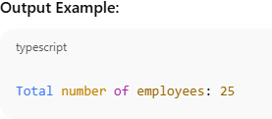
• Lab 2: Create a PL/SQL block that calculates the total sales from an orders table.

DECLARE
v_total_sales NUMBER(10,2); -- Variable to store total sales

BEGIN
-- Calculate total sales from the orders table
SELECT SUM(order_amount) INTO v_total_sales

FROM orders;
-- Display the total sales
DBMS_OUTPUT.PUT_LINE('Total Sales: $' || v_total_sales);END;

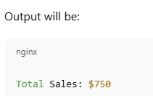

17. PL/SQL Control Structures Theory Questions:

1. What are control structures in PL/SQL? Explain the IF-THEN and LOOP control structures.
1. What are Control Structures in PL/SQL?
Control structures allow you to control the flow of execution in a PL/SQL block.
They help in making decisions, repeating actions, or branching code based on conditions.
Types of Control Structures:
- Conditional Statements → IF-THEN, IF-THEN-ELSE, CASE
- Looping Statements → LOOP, WHILE LOOP, FOR LOOP
- Sequential Control Statements → GOTO, EXIT, CONTINUE

1.Explain the IF-THEN and LOOP control structures.

1. IF-THEN Control Structure
- Purpose: Execute a block of code only if a specific condition is true.

2. LOOP Control Structure
- Purpose: Repeat a block of code multiple times, either a fixed number of times or until a condition is met.

- Types:
  - Simple LOOP – repeats indefinitely until EXIT is used.
  - WHILE LOOP – repeats while a condition is true.
  - FOR LOOP – repeats a fixed number of times.

In short:
- IF-THEN → Conditional execution (runs only if a condition is true).
- LOOP → Repeated execution (runs multiple times until a condition or fixed count).

2. How do control structures in PL/SQL help in writing complex queries?
Control structures in PL/SQL (IF-THEN, LOOP, CASE, WHILE, FOR) let you add procedural logic to your SQL operations, making queries more powerful and flexible.
- Conditional Logic (IF-THEN, CASE):
  - Allows execution of SQL statements only when certain conditions are met.
  - Example: Update salaries only if they are below a threshold.
- Repetition (LOOP, FOR, WHILE):
  - Lets you process multiple rows or repeated actions without writing multiple SQL statements.
  - Example: Apply a discount to all orders in a table using a loop.
- Error Handling (EXCEPTION):
  - Handles errors gracefully while running queries, ensuring complex operations don’t fail abruptly.
- Combining SQL with Procedural Logic:
  - Enables you to write complex operations in a single PL/SQL block, like counting, conditional updates, and logging changes simultaneously. LAB EXERCISES:

Lab 1: Write a PL/SQL block using an IF-THEN condition to check the department of an employee.
DECLARE
v_emp_id NUMBER := 101; -- Employee ID to check
v_dept_id NUMBER; -- Variable to store department ID
BEGIN
-- Get the employee's department ID
SELECT department_id
INTO v_dept_id
FROM employees
WHERE employee_id = v_emp_id;
-- Check the department using IF-THEN
IF v_dept_id = 10 THEN
DBMS_OUTPUT.PUT_LINE('Employee works in the Administration department.');
ELSIF v_dept_id = 20 THEN
DBMS_OUTPUT.PUT_LINE('Employee works in the Marketing department.');
ELSE
DBMS_OUTPUT.PUT_LINE('Employee works in another department with ID: ' || v_dept_id);
END IF;
EXCEPTION
WHEN NO_DATA_FOUND THEN
DBMS_OUTPUT.PUT_LINE('Employee with ID ' || v_emp_id || ' not found.');
WHEN OTHERS THEN
DBMS_OUTPUT.PUT_LINE('An unexpected error occurred: ' || SQLERRM);

• Lab 2: Use a FOR LOOP to iterate through employee records and display their names.
BEGIN
-- Loop through all employees
FOR emp_rec IN (SELECT first_name, last_name FROM employees) LOOP
-- Display the employee's full name
DBMS_OUTPUT.PUT_LINE(emp_rec.first_name || ' ' || emp_rec.last_name);
END LOOP;
END;
/
18. SQL Cursors Theory Questions:
1. What is a cursor in PL/SQL? Explain the difference between implicit and explicit cursors.
What is a Cursor in PL/SQL?
A cursor in PL/SQL is a pointer or handle that allows you to fetch and process rows returned by a SQL query one at a time.
In simpler terms, when a SQL query returns multiple rows, a cursor lets PL/SQL loop through these rows and work with them individually.
Explain the difference between implicit and explicit cursors.
Feature | Implicit Cursor | Explicit Cursor
Declaration | Automatic (no need to declare) | Must be declared explicitly
Use | Single-row queries | Multi-row queries
Fetching rows | Not required | Must explicitly fetch rows
Attributes | SQL%ROWCOUNT, SQL%FOUND, etc. | %FOUND, %NOTFOUND, %ROWCOUNT, %ISOPEN
Example | SELECT INTO | Cursor declared with CURSOR keyword

2. When would you use an explicit cursor over an implicit one?
Use implicit cursors for single-row operations or simple DML.
Use explicit cursors when you need row-by-row processing, multiple rows, or more control.
LAB EXERCISES:
• Lab 1: Write a PL/SQL block using an explicit cursor to retrieve and display employee details.
DECLARE
-- Step 1: Declare the explicit cursor
CURSOR emp_cursor IS
SELECT employee_id, first_name, last_name, department_id, salary
FROM employees;
-- Variables to hold fetched data
v_emp_id employees.employee_id%TYPE;
v_first_name employees.first_name%TYPE;
v_last_name employees.last_name%TYPE;
v_dept_id employees.department_id%TYPE;
v_salary employees.salary%TYPE;
BEGIN
-- Step 2: Open the cursor
OPEN emp_cursor;
-- Step 3: Loop through the cursor
LOOP
FETCH emp_cursor INTO v_emp_id, v_first_name, v_last_name, v_dept_id, v_salary;
EXIT WHEN emp_cursor%NOTFOUND;
-- Step 4: Display employee details
DBMS_OUTPUT.PUT_LINE('ID: ' || v_emp_id ||
', Name: ' || v_first_name || ' ' || v_last_name ||
', Dept: ' || v_dept_id ||
', Salary: ' || v_salary);
END LOOP;
-- Step 5: Close the cursor
CLOSE emp_cursor;
END;

• Lab 2: Create a cursor to retrieve all courses and display them one by one.
DECLARE
-- Step 1: Declare the cursor
CURSOR course_cursor IS
SELECT course_id, course_name, course_duration
FROM courses;
-- Variables to hold fetched data
v_course_id courses.course_id%TYPE;
v_course_name courses.course_name%TYPE;
v_course_duration courses.course_duration%TYPE;
BEGIN
-- Step 2: Open the cursor
OPEN course_cursor;
-- Step 3: Loop through the cursor
LOOP
FETCH course_cursor INTO v_course_id, v_course_name, v_course_duration;
EXIT WHEN course_cursor%NOTFOUND;
-- Step 4: Display course details
DBMS_OUTPUT.PUT_LINE('ID: ' || v_course_id ||
', Name: ' || v_course_name ||
', Duration: ' || v_course_duration);
END LOOP;
-- Step 5: Close the cursor
CLOSE course_cursor;
END;

19. Rollback and Commit Savepoint Theory Questions:
1. Explain the concept of SAVEPOINT in transaction management. How do ROLLBACK and COMMIT interact with savepoints?
SAVEPOINT → partial undo within a transaction.
ROLLBACK TO SAVEPOINT → undo changes after the savepoint.
COMMIT → makes all changes permanent and clears savepoints.
2. When is it useful to use savepoints in a database transaction?
Savepoints are useful in a database transaction when you want to partially undo changes without rolling back the entire transaction.
Typical scenarios include:
- Complex Transactions: When a transaction has multiple steps, and some may fail while others should still be kept.
- Error Handling: If an error occurs in the middle, you can rollback to a savepoint instead of aborting everything.
- Conditional Updates: When certain operations depend on conditions, you can undo only the parts that failed.
- Testing Changes: Allows experimenting with changes within a transaction, rolling back selectively before committing.

LAB EXERCISES:
• Lab 1: Perform a transaction where you create a savepoint, insert records, then rollback to the savepoint.
BEGIN
-- Step 1: Insert the first record
INSERT INTO courses (course_id, course_name, course_duration)
VALUES (101, 'Mathematics', '6 months');
-- Step 2: Create a savepoint after the first insert
SAVEPOINT before_second_insert;
-- Step 3: Insert the second record
INSERT INTO courses (course_id, course_name, course_duration)
VALUES (102, 'Physics', '4 months');
-- Step 4: Something goes wrong, rollback to the savepoint
ROLLBACK TO before_second_insert;
-- Step 5: Commit the transaction (only the first insert will remain)
COMMIT;
DBMS_OUTPUT.PUT_LINE('Transaction completed. Second insert rolled back, first insert committed.');
EXCEPTION
WHEN OTHERS THEN
ROLLBACK; -- Rollback everything in case of unexpected errors
DBMS_OUTPUT.PUT_LINE('Error occurred, transaction rolled back.');
END;
/

• Lab 2: Commit part of a transaction after using a savepoint and then rollback the remaining changes
BEGIN
-- Step 1: Insert the first record
INSERT INTO courses (course_id, course_name, course_duration)
VALUES (201, 'Chemistry', '5 months');
-- Step 2: Create a savepoint after the first insert
SAVEPOINT after_first_insert;
-- Step 3: Insert the second record
INSERT INTO courses (course_id, course_name, course_duration)
VALUES (202, 'Biology', '4 months');
-- Step 4: Commit the transaction so far (only first insert is committed)
COMMIT;
DBMS_OUTPUT.PUT_LINE('First insert committed.');
-- Step 5: Insert a third record (this is still uncommitted)
INSERT INTO courses (course_id, course_name, course_duration)
VALUES (203, 'English', '3 months');
-- Step 6: Oops! Rollback the remaining uncommitted changes (third insert)
ROLLBACK;
DBMS_OUTPUT.PUT_LINE('Remaining uncommitted changes rolled back.');
EXCEPTION
WHEN OTHERS THEN
ROLLBACK;
DBMS_OUTPUT.PUT_LINE('Error occurred, transaction rolled back.');
END;

EXTRA LAB PRACTISE FOR DATABASE CONCEPTS
1. Introduction to SQL LAB EXERCISES:
• Lab 3: Create a database called library_db and a table books with columns: book_id, title, author, publisher, year_of_publication, and price. Insert five records into the table.
-- Step 1: Create the database
CREATE DATABASE library_db;
-- Step 2: Connect to the newly created database (depends on your SQL environment)
-- For example, in MySQL:
-- USE library_db;
-- Step 3: Create the table 'books'
CREATE TABLE books (
book_id INT PRIMARY KEY,
title VARCHAR(100) NOT NULL,
author VARCHAR(100) NOT NULL,
publisher VARCHAR(100),
year_of_publication YEAR,
price DECIMAL(10,2));
-- Step 4: Insert five records into the 'books' table
INSERT INTO books (book_id, title, author, publisher, year_of_publication, price)
VALUES
(1, 'The Alchemist', 'Paulo Coelho', 'HarperOne', 1988, 15.99),
(2, '1984', 'George Orwell', 'Secker & Warburg', 1949, 12.50),
(3, 'To Kill a Mockingbird', 'Harper Lee', 'J.B. Lippincott & Co.', 1960, 14.00),
(4, 'The Great Gatsby', 'F. Scott Fitzgerald', 'Scribner', 1925, 10.75),
(5, 'Moby Dick', 'Herman Melville', 'Harper & Brothers', 1851, 18.25);-- Step 5: Verify the inserted recordsSELECT * FROM books;
Output:
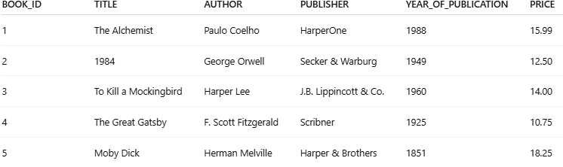
• Lab 4: Create a table members in library_db with columns: member_id, member_name, date_of_membership, and email. Insert five records into this table.
-- Step 1: Connect to the database (depends on your SQL environment)
-- For example, in MySQL:
-- USE library_db;
-- Step 2: Create the 'members' table
CREATE TABLE members (
member_id INT PRIMARY KEY,
member_name VARCHAR(100) NOT NULL,
date_of_membership DATE NOT NULL,
email VARCHAR(100) UNIQUE);
-- Step 3: Insert five records into the 'members' table
INSERT INTO members (member_id, member_name, date_of_membership, email)
VALUES
(1, 'Alice Johnson', '2023-01-15', 'alice.johnson@example.com'),
(2, 'Bob Smith', '2022-11-20', 'bob.smith@example.com'),
(3, 'Charlie Brown', '2023-03-05', 'charlie.brown@example.com'),
(4, 'Diana Prince', '2022-12-10', 'diana.prince@example.com'),
(5, 'Ethan Hunt', '2023-02-28', 'ethan.hunt@example.com')
-- Step 4: Verify the inserted recordsSELECT * FROM members;
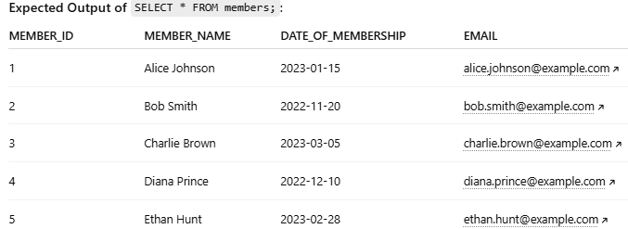

2. SQL Syntax LAB EXERCISES:
• Lab 3: Retrieve all members who joined the library before 2022. Use appropriate SQL syntax with WHERE and ORDER BY.
SELECT member_id, member_name, date_of_membership, email
FROM members
WHERE date_of_membership < DATE '2022-01-01'
ORDER BY date_of_membership ASC;
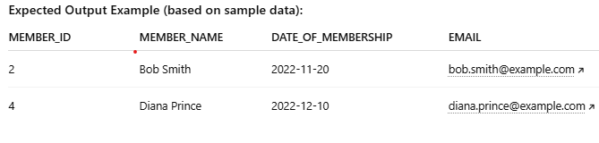
• Lab 4: Write SQL queries to display the titles of books published by a specific author. Sort the results by year_of_publication in descending order.
SELECT title, year_of_publication
FROM books
WHERE author = 'George Orwell' -- Replace with the desired author
ORDER BY year_of_publication DESC;
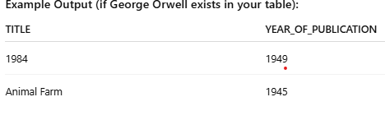
3. SQL Constraints LAB EXERCISES:
• Lab 3: Add a CHECK constraint to ensure that the price of books in the books table is greater than 0.
Input: Valid insert
INSERT INTO books (book_id, title, author, publisher, year_of_publication, price)
VALUES (6, 'Clean Code', 'Robert Martin', 'Prentice Hall', 2008, 25.50);
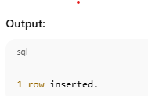

Input: Invalid insert (price = 0)
INSERT INTO books (book_id, title, author, publisher, year_of_publication, price)
VALUES (7, 'Invalid Book', 'Test Author', 'Test Publisher', 2023, 0);
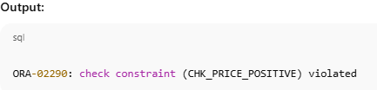

• Lab 4: Modify the members table to add a UNIQUE constraint on the email column, ensuring that each member has a unique email address.
UNIQUE constraint on members.email
Input: Valid insert (new email)
INSERT INTO members (member_id, member_name, date_of_membership, email)
VALUES (6, 'Frank Castle', '2023-04-01', 'frank.castle@example.com');
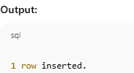
Input: Invalid insert (duplicate email)
INSERT INTO members (member_id, member_name, date_of_membership, email)
VALUES (7, 'Jane Doe', '2023-04-02', 'alice.johnson@example.com');
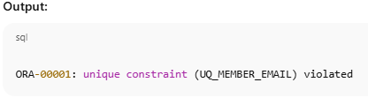
4. Main SQL Commands and Sub-commands (DDL) LAB EXERCISES:
• Lab 3: Create a table authors with the following columns: author_id, first_name, last_name, and country. Set author_id as the primary key.
CREATE TABLE authors (
author_id INT PRIMARY KEY,
first_name VARCHAR(50) NOT NULL,
last_name VARCHAR(50) NOT NULL,
country VARCHAR(50));
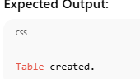
• Lab 4: Create a table publishers with columns: publisher_id, publisher_name, contact_number, and address. Set publisher_id as the primary key and contact_number as unique.

CREATE TABLE publishers (
publisher_id INT PRIMARY KEY,
publisher_name VARCHAR(100) NOT NULL,
contact_number VARCHAR(15) UNIQUE,
address VARCHAR(200)
);
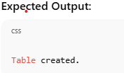

5. ALTER Command LAB EXERCISES:

• Lab 3: Add a new column genre to the books table. Update the genre for all existing records.
Step 1: Add the genre column
Input:
ALTER TABLE books
ADD genre VARCHAR(50);

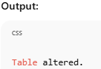
Step 2: Update the genre for existing books
Input (example genres for existing records):
UPDATE books
SET genre = CASE book_id
WHEN 1 THEN 'Fiction'
WHEN 2 THEN 'Dystopian'
WHEN 3 THEN 'Classic'
WHEN 4 THEN 'Classic'
WHEN 5 THEN 'Adventure'
END;
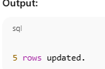
Step 3: Verify the update
Input:
SELECT book_id, title, genre FROM books;
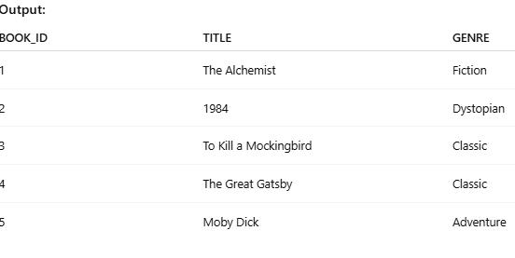
• Lab 4: Modify the members table to increase the length of the email column to 100 characters.
ALTER TABLE members
MODIFY COLUMN email VARCHAR(100);
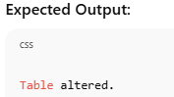
6. DROP Command LAB EXERCISES:
• Lab 3: Drop the publishers table from the database after verifying its structure.
Input;
DESCRIBE publishers;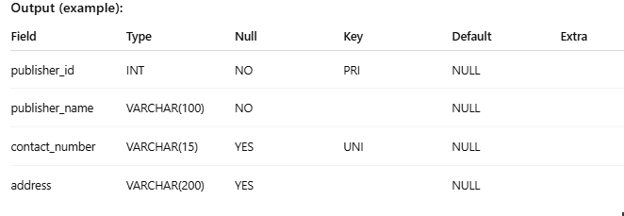
Step 2: Drop the table
Input:
DROP TABLE publishers;
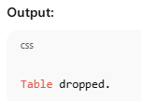

• Lab 4: Create a backup of the members table and then drop the original members table
Input (before)
members
id | name | email
1 | Alice | alice@test.com
2 | Bob | bob@test.com
CREATE TABLE members_backup AS
SELECT * FROM members;
DROP TABLE members;
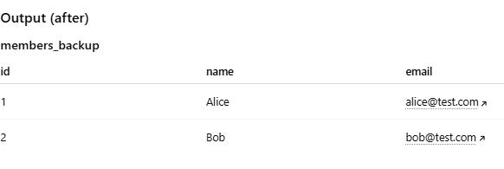

7. Data Manipulation Language (DML) LAB EXERCISES:
• Lab 4: Insert three new authors into the authors table, then update the last name of one of the authors.
INSERT INTO authors (author_id, first_name, last_name)
VALUE(1, 'John', 'Smith'),(2, 'Emily', 'Brown'),(3, 'Michael', 'Clark');
UPDATE authors
SET last_name = 'Johnson'
WHERE author_id = 2;
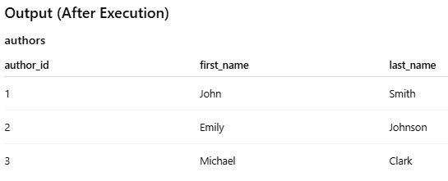
• Lab 5: Delete a book from the books table where the price is higher than $100.
DELETE FROM books
WHERE price > 100
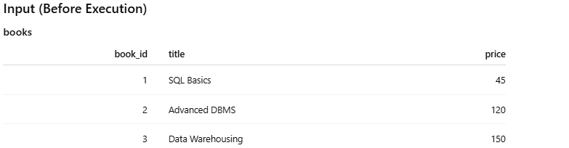

Module 4 – Introduction to DBMS
Introduction to SQL
Theory Questions:
Questions: 1. What is SQL, and why is it essential in database management?.
SQL (Structured Query Language) is a standard programming language used to create, manage, and manipulate relational databases.
What is SQL?
SQL allows users to:
- Create databases and tables
- Insert, update, delete, and retrieve data
- Control access to data
- Maintain data integrity
It works with relational database systems such as MySQL, PostgreSQL, Oracle, and SQL Server.
Why is SQL essential in database management?
- Data Retrieval
  - SQL makes it easy to retrieve specific data using queries like SELECT
.
- Data Manipulation
  - It allows inserting (INSERT), updating (UPDATE), and deleting (DELETE) records efficiently.

3.Database Structure Management
  - SQL is used to create and modify database objects such as tables, views, indexes, and schemas.

4.Data Integrity and Accuracy
  - Constraints (PRIMARY KEY, FOREIGN KEY, UNIQUE, NOT NULL) ensure data consistency and reliability.
5.Security and Access Control
  - SQL manages user permissions using GRANT and REVOKE.
6. Standardized Language
  - SQL is an international standard, so skills are transferable across different database systems.
7.Efficient Handling of Large Data
  - SQL can process large volumes of data quickly and efficiently.

2. Explain the difference between DBMS and RDBMS.
Aspect | DBMS (Database Management System) | RDBMS (Relational Database Management System)
Definition | Software that manages databases and allows data storage, retrieval, and manipulation | A type of DBMS based on the relational model, where data is stored in tables
Data Structure | Stores data as files or hierarchical structures | Stores data in tables (rows and columns)
Relationships | Does not support relationships between data | Supports relationships using primary keys and foreign keys
Normalization | Does not support normalization | Supports normalization to reduce data redundancy
Data Integrity | Limited data integrity | Strong data integrity using constraints
Scalability | Suitable for small applications | Suitable for large, complex applications
Examples | File system, XML databases | MySQL, PostgreSQL, Oracle, SQL Server
Security | Basic security features | Advanced security and access control

3. Describe the role of SQL in managing relational databases.
Role of SQL in simple English:
- Create databases and tables
SQL is used to define the structure of databases and tables.
- Insert, update, and delete data
SQL commands help manage data stored in tables.
- Retrieve data
SQL allows users to fetch required data using SELECT queries.
- Manage relationships
SQL maintains relationships between tables using primary keys and foreign keys.
- Ensure data integrity
Constraints ensure data is accurate and consistent.
- Control security and access
SQL manages user permissions and protects data.
4. What are the key features of SQL?
The key features of SQL (Structured Query Language) are:
- Easy to use
SQL uses simple and readable commands.
- Data retrieval
Allows fast and efficient data fetching using SELECT.
- Data manipulation
Supports inserting, updating, and deleting data (INSERT, UPDATE, DELETE).
- Database structure management
Used to create and modify databases and tables (CREATE, ALTER, DROP).
- Data integrity
Ensures accuracy using constraints like PRIMARY KEY, FOREIGN KEY, UNIQUE, and NOT NULL.
- Security and access control
Manages user permissions with GRANT and REVOKE.
- Standard language
Works across many database systems like MySQL, Oracle, and SQL Server.
- Scalable and efficient
Handles large amounts of data effectively.

LAB EXERCISES:
• Lab 1: Create a new database named school_db and a table called students with the following columns: student_id, student_name, age, class, and address.
Step 1: Create a new database
CREATE DATABASE schooldboct
-- Step 2: Use the new database
USE schooldboct;
-- Step 3: Create the students table
CREATE TABLE students (student_id INT PRIMARY KEY AUTO_INCREMENT, student_name VARCHAR(100) , age INT, class VARCHAR(50), address VARCHAR(255));

• Lab 2: Insert five records into the students table and retrieve all records using the SELECT statement.
INSERT INTO students (student_name, age, class, address)
VALUES
('Alice Johnson', 14, '8th Grade', '123 Maple Street'),
('Brian Smith', 15, '9th Grade', '456 Oak Avenue'),
('Catherine Lee', 13, '7th Grade', '789 Pine Road'),
('David Brown', 16, '10th Grade', '321 Cedar Lane'),
('Emma Wilson', 14, '8th Grade', '654 Birch Boulevard');

Output:
student_id | student_name | age | class | address
1 | Alice Johnson | 14 | 8th Grade | 123 Maple Street
2 | Brian Smith | 15 | 9th Grade | 456 Oak Avenue
3 | Catherine Lee | 13 | 7th Grade | 789 Pine Road
4 | David Brown | 16 | 10th Grade | 321 Cedar Lane
5 | Emma Wilson | 14 | 8th Grade | 654 Birch Boulevard

2. SQL Syntax Theory Questions:
1. What are the basic components of SQL syntax?
SQL syntax consists of different parts or components that are used to perform operations on a database. The main components are:
- Keywords
  - Reserved words that SQL recognizes and uses to perform operations.
  - Examples: SELECT, INSERT, UPDATE, DELETE, CREATE, DROP.
- Identifiers
  - Names given to database objects like tables, columns, and databases.
  - Examples: students (table name), student_name (column name).
- Expressions
  - Combinations of symbols, column names, and values that produce a result.
  - Example: age + 1, 'Alice' || ' Johnson' (concatenation).
- Clauses
  - Part of SQL statements that perform specific functions.
  - Examples: WHERE, FROM, GROUP BY, ORDER BY.
- Predicates
  - Conditions used to filter data in queries.
  - Examples: =, >, <, LIKE, BETWEEN, IN.
- Operators
  - Symbols that perform operations on data.
  - Examples: +, -, *, /, AND, OR, NOT.
- Statements / Commands
  - Complete instructions executed by the database.
  - Examples:
    - SELECT * FROM students;
    - INSERT INTO students VALUES (...);

2. Write the general structure of an SQL SELECT statement.
SELECT column1, column2, ...
FROM table_name
WHERE condition
GROUP BY column_name
HAVING condition
ORDER BY column_name ASC|DESC;
Explanation of each part:
- SELECT column1, column2, ...
  - Specifies the columns you want to retrieve.
  - Use * to select all columns.
- FROM table_name
  - Specifies the table from which to retrieve the data.
- WHERE condition (optional)
  - Filters the rows based on a condition.
  - Example: WHERE age > 14
- GROUP BY column_name (optional)
  - Groups rows that have the same values in a column.
  - Often used with aggregate functions like COUNT, SUM.
- HAVING condition (optional)
  - Filters groups after aggregation.
  - Example: HAVING COUNT(student_id) > 2
- ORDER BY column_name ASC|DESC (optional)
  - Sorts the result in ascending (ASC) or descending (DESC) order.

3. Explain the role of clauses in SQL statements
Key Roles of Clauses:
- SELECT clause
  - Specifies which columns to retrieve from the table.
  - Example: SELECT student_name, age
- FROM clause
  - Specifies the table(s) to get data from.
  - Example: FROM students
- WHERE clause
  - Filters rows based on a condition.
  - Example: WHERE age > 14
- GROUP BY clause
  - Groups rows with the same values in one or more columns.
  - Example: GROUP BY class
- HAVING clause
  - Filters groups after aggregation (used with GROUP BY).
  - Example: HAVING COUNT(student_id) > 2
- ORDER BY clause
  - Sorts the result ascending (ASC) or descending (DESC).
  - Example: ORDER BY age DESC

LAB EXERCISES:
• Lab 1: Write SQL queries to retrieve specific columns (student_name and age) from the students table.
SELECT student_name, age
FROM students;
student_name | age
Alice Johnson | 14
Brian Smith | 15
Catherine Lee | 13
David Brown | 16
Emma Wilson | 14

• Lab 2: Write SQL queries to retrieve all students whose age is greater than 10.
SELECT * FROM students ,WHERE age > 10;
student_id | student_name | age | class | address
1 | Alice Johnson | 14 | 8th Grade | 123 Maple Street
2 | Brian Smith | 15 | 9th Grade | 456 Oak Avenue
3 | Catherine Lee | 13 | 7th Grade | 789 Pine Road
4 | David Brown | 16 | 10th Grade | 321 Cedar Lane
5 | Emma Wilson | 14 | 8th Grade | 654 Birch Boulevard

3. SQL Constraints Theory Questions:
1. What are constraints in SQL? List and explain the different types of constraints.
Types of Constraints in SQL
- PRIMARY KEY
  - Uniquely identifies each record in a table.
  - Cannot have NULL values.
  - Example:
  - student_id INT PRIMARY KEY
- FOREIGN KEY
  - Maintains relationship between two tables.
  - Values must match a primary key in another table.
  - Example:
  - class_id INT,
  - FOREIGN KEY (class_id) REFERENCES classes(class_id)
- UNIQUE
  - Ensures that all values in a column are different.
  - Example:
  - email VARCHAR(100) UNIQUE
- NOT NULL
  - Ensures that a column cannot have empty (NULL) values.
  - Example:
  - student_name VARCHAR(100) NOT NULL
- CHECK
  - Ensures that values in a column satisfy a specific condition.
  - Example:
  - age INT CHECK (age >= 5)
- DEFAULT
  - Assigns a default value to a column if no value is provided.
  - Example:
status VARCHAR(20) DEFAULT 'Active'

2. How do PRIMARY KEY and FOREIGN KEY constraints differ?
Feature | PRIMARY KEY | FOREIGN KEY
Purpose | Uniquely identifies each row in a table | Maintains a link between two tables (establishes a relationship)
Uniqueness | Must be unique for each row | Values can repeat, but must match a value in the referenced table
NULL Values | Cannot be NULL | Can be NULL (optional), depending on design
Defined In | Table that stores the main data | Table that references another table’s primary key
Example | student_id INT PRIMARY KEY | class_id INT, FOREIGN KEY (class_id) REFERENCES classes(class_id)
Relation | Independent column in its own table | Dependent on the primary key of another table

3. What is the role of NOT NULL and UNIQUE constraints?
Role of NOT NULL and UNIQUE Constraints in SQL
1. NOT NULL Constraint
- Ensures that a column cannot have empty (NULL) values.
- Used when a field must always contain a value.
Example:
student_name VARCHAR(100) NOT NULL;
- This means every student must have a name. You cannot insert a row without a value for student_name.
Role:
- Prevents missing data in important columns.
- Ensures data completeness.

2. UNIQUE Constraint
- Ensures that all values in a column are different.
- No two rows can have the same value in a UNIQUE column.
Example:
email VARCHAR(100) UNIQUE;
- This ensures that no two students can have the same email address.
Role:
- Prevents duplicate data.
- Ensures data integrity for fields that must be unique (like emails, IDs, etc.).

LAB EXERCISES: • Lab 1: Create a table teachers with the following columns: teacher_id (Primary Key), teacher_name (NOT NULL), subject (NOT NULL), and email (UNIQUE).
-- Create the teachers table
CREATE TABLE teachers (
teacher_id INT PRIMARY KEY,
teacher_name VARCHAR(100) NOT NULL,
subject VARCHAR(50) NOT NULL,
email VARCHAR(100) UNIQUE
);
• Lab 2: Implement a FOREIGN KEY constraint to relate the teacher_id from the teachers table with the students table.
-- Step 1: Add teacher_id column to students table
ALTER TABLE students
ADD COLUMN teacher_id INT;
-- Step 2: Add FOREIGN KEY constraint
ALTER TABLE students
ADD CONSTRAINT fk_teacher
FOREIGN KEY (teacher_id) REFERENCES teachers(teacher_id);

4. Main SQL Commands and Sub-commands (DDL) Theory Questions:
1. Define the SQL Data Definition Language (DDL).
Data Definition Language (DDL) is a part of SQL used to define, create, modify, and delete the structure of database objects such as databases, tables, views, and indexes.
Key Points:
- DDL deals with the schema (structure) of the database, not the data itself.
- Changes made using DDL commands are usually permanent.
2. Explain the CREATE command and its syntax
The CREATE command in SQL is a DDL (Data Definition Language) command used to create new database objects such as databases, tables, views, and indexes.
Purpose of CREATE
- Creates the structure of a database or table.
- Defines columns, data types, and constraints.
General Syntax
Create a Database
CREATE DATABASE database_name;
Create a Table
CREATE TABLE table_name (
column1 datatype constraint,
column2 datatype constraint,
);
3. What is the purpose of specifying data types and constraints during table creation?
Data types and constraints are specified during table creation to make sure the database stores correct and valid data.
Data types decide what type of data a column can store (number, text, etc.).
Constraints set rules for the data, like no empty values or no duplicates.
In short :-They help keep data accurate, consistent, and error-free.
LAB EXERCISES:
• Lab 1: Create a table courses with columns: course_id, course_name, and course_credits. Set the course_id as the primary key.
-- Create the courses table
CREATE TABLE courses ( course_id INT PRIMARY KEY, course_name VARCHAR(100),course_credits INT);
• Lab 2: Use the CREATE command to create a database university_db.
CREATE DATABASE university_db;

5. ALTER Command Theory Questions:
1. What is the use of the ALTER command in SQL?
The ALTER command in SQL is used to modify the structure of an existing database object, mainly a table.
What ALTER is used for:
- Add new columns to a table
- Modify existing columns (data type or size)
- Delete columns from a table
- Add or remove constraints (PRIMARY KEY, FOREIGN KEY, etc.)
Example:
ALTER TABLE students ADD email VARCHAR(100);
Simple words:
The ALTER command is used to change the structure of a table after it has been created, without deleting the table.

2. How can you add, modify, and drop columns from a table using ALTER? ALTER TABLE students
ADD email VARCHAR(100);
👉 Adds a new column email to the students table.
2. Modify a Column
sql
Copy code
ALTER TABLE students
MODIFY email VARCHAR(150);
👉 Changes the data type or size of the email column.
(MySQL syntax)
3. Drop a Column
sql
Copy code
ALTER TABLE students
DROP email;
👉 Removes the email column from the table.
LAB EXERCISES: • Lab 1: Modify the courses table by adding a column course_duration using the ALTER command. • Lab 2: Drop the course_credits column from the courses table
LAB EXERCISES:
• Lab 1: Modify the courses table by adding a column course_duration using the ALTER command.
ALTER TABLE courses ADD course_duration INT;
• Lab 2: Drop the course_credits column from the courses table
ALTER TABLE coursesDROP COLUMN course_credits;

6. DROP Command Theory Questions:
1. What is the function of the DROP command in SQL?
The DROP command is used to remove tables or databases completely from the system. It’s like permanently deleting a file—you cannot recover it unless you have a backup.
When you use the DROP TABLE command, it permanently removes the table and its data from the database. Here are the key implications:
- All Data Is Lost
  - Every row in the table is deleted permanently.
  - Example: If students table is dropped, all student records are gone.
- Table Structure Is Removed
  - Columns, constraints (PRIMARY KEY, FOREIGN KEY, NOT NULL, etc.), and indexes are deleted.
- Relationships Are Affected
  - Any foreign key relationships pointing to this table will break or cause errors.
- Cannot Be Recovered Directly
  - Once dropped, the table cannot be restored unless there is a backup.
- Cascading Effects (if supported)
  - Some databases allow CASCADE, which will also drop dependent objects like views or constraints automatically.

• Lab 1: Drop the teachers table from the school_db database.
-- Switch to the school_db database
USE school_db;
-- Drop the teachers table
DROP TABLE teachers;

• Lab 2: Drop the students table from the school_db database and verify that the table has been removed
-- Step 1: Switch to the school_db database
USE school_db;
-- Step 2: Drop the teachers table
DROP TABLE teachers;
-- Step 3: Drop the students table
DROP TABLE students;
-- Step 4: Verify that the tables have been removed
SHOW TABLES;
7. Data Manipulation Language (DML)
Theory Questions:
1. Define the INSERT, UPDATE, and DELETE commands in SQL
1. INSERT Command
The INSERT command is used to add new records (rows) to a table.
2. UPDATE Command
The UPDATE command is used to modify existing records in a table.
3. DELETE Command
The DELETE command is used to remove records from a table.
2. What is the importance of the WHERE clause in UPDATE and DELETE operations
The WHERE clause is important in UPDATE and DELETE because it selects specific records to change or remove.
- It prevents updating or deleting all rows in a table.
- It helps avoid accidental data loss.
It ensures only required data is affected.

LAB EXERCISES: • Lab 1: Insert three records into the courses table using the INSERT command
INSERT INTO students (student_id, student_name, age, class, address)
VALUES
(1, 'Alice Johnson', 14, '8th Grade', '123 Maple Street'),
(2, 'Brian Smith', 15, '9th Grade', '456 Oak Avenue'),
(3, 'Catherine Lee', 13, '7th Grade', '789 Pine Road');
Lab 2: Update the course duration of a specific course using the UPDATE command.
UPDATE courses
SET duration = '5 Months'
WHERE course_name = 'Database Systems';
Lab 3: Delete a course with a specific course_id from the courses table using the DELETE command.
For example, to delete the course with course_id = 103:
DELETE FROM courses
WHERE course_id = 103;

8. Data Query Language (DQL)
Theory Questions:
1. What is the SELECT statement, and how is it used to query data?
SELECT Statement in SQL
The SELECT statement is used to retrieve (query) data from one or more tables in a database.
It does not change the data, it only displays it.
2. Explain the use of the ORDER BY and WHERE clauses in SQL queries.
1️⃣ WHERE Clause
Purpose:
The WHERE clause is used to filter rows based on a condition. Only the rows that meet the condition are returned.
2️⃣ ORDER BY Clause
Purpose:
The ORDER BY clause is used to sort the query results in ascending (ASC) or descending (DESC) order.
3️⃣ Using Both Together
You can filter and sort at the same time:

LAB EXERCISES: • Lab 1: Retrieve all courses from the courses table using the SELECT statement.
  - SELECT *
FROM courses;
Lab 2: Sort the courses based on course_duration in descending order using ORDER BY.
  - SELECT *
FROM courses
ORDER BY duration DESC;
Lab 3: Limit the results of the SELECT query to show only the top two courses using LIMIT
  - SELECT *
FROM courses
ORDER BY duration DESC
LIMIT 2;

9. Data Control Language (DCL)
Theory Questions:
1. What is the purpose of GRANT and REVOKE in SQL?
GRANT
Purpose:
To give users or roles specific permissions on database objects.
REVOKE
Purpose:
To remove previously granted permissions from users or roles.
Command | Purpose | Effect
GRANT | Give permissions | Enables access
REVOKE | Remove permissions | Restricts access

2. How do you manage privileges using these commands?
GRANT → Assign privileges
REVOKE → Remove privileges
Roles simplify management
Grant options control privilege sharing

LAB EXERCISES:
• Lab 1: Create two new users user1 and user2 and grant user1 permission to SELECT from the courses table.
-- Create two users
CREATE USER user1 IDENTIFIED BY password1;
CREATE USER user2 IDENTIFIED BY password2;

-- Grant SELECT permission on the courses table to user1
GRANT SELECT ON courses TO user1;
• Lab 2: Revoke the INSERT permission from user1 and give it to user2 .
-- Revoke INSERT permission from user1
REVOKE INSERT ON courses FROM user1;
-- Grant INSERT permission to user2
GRANT INSERT ON courses TO user2;

10. Transaction Control Language (TCL)
Theory Questions:
1. What is the purpose of the COMMIT and ROLLBACK commands in SQL?
=>COMMIT
Purpose:
To permanently save all changes made during the current transaction.

2. Explain how transactions are managed in SQL databases.
=> A transaction begins when a database operation starts and ends when it is committed or rolled back.
Example:
BEGIN TRANSACTION;
UPDATE accounts SET balance = balance - 100 WHERE acc_id = 1;
UPDATE accounts SET balance = balance + 100 WHERE acc_id = 2;
COMMIT;
Transaction Control Commands (TCL)
These commands are used to manage transactions:
Command | Purpose
BEGIN TRANSACTION / START TRANSACTION | Starts a transaction
COMMIT | Saves changes permanently
ROLLBACK | Undoes uncommitted changes
SAVEPOINT | Sets a rollback point within a transaction
Example with SAVEPOINT:
BEGIN;
INSERT INTO orders VALUES (1, 'Book');
SAVEPOINT sp1;
INSERT INTO orders VALUES (2, 'Pen');
ROLLBACK TO sp1;
COMMIT;

LAB EXERCISES:
• Lab 1: Insert a few rows into the courses table and use COMMIT to save the changes.
Create two users and grant SELECT permission on courses to user1
-- Create users
CREATE USER user1 IDENTIFIED BY password1;
CREATE USER user2 IDENTIFIED BY password2;

-- Grant SELECT permission on courses table to user1
GRANT SELECT ON courses TO user1;

2. Insert rows into the courses table and COMMIT the changes
-- Insert sample records into courses table
INSERT INTO courses (course_id, course_name, instructor, credits)
VALUES (1, 'Mathematics', 'Mr. Allen', 4)
INSERT INTO courses (course_id, course_name, instructor, credits)
VALUES (2, 'Science', 'Ms. Carter', 3);
INSERT INTO courses (course_id, course_name, instructor, credits)
VALUES (3, 'History', 'Mr. Brown', 2);
-- Save the changes permanently
COMMIT;

• Lab 2: Insert additional rows, then use ROLLBACK to undo the last insert operation.
BEGIN TRANSACTION;
-- Start a transaction (optional if autocommit is off)
BEGIN TRANSACTION;
-- Insert the first additional row
INSERT INTO courses (course_id, course_name, instructor, credits)
VALUES (6, 'Physics', 'Dr. Green', 4);
-- Insert the second additional row (the one we want to undo)
INSERT INTO courses (course_id, course_name, instructor, credits)
VALUES (7, 'Chemistry', 'Dr. White', 3);
-- Undo the last insert operation
ROLLBACK;

INSERT INTO courses (course_id, course_name, instructor, credits)
VALUES (6, 'Physics', 'Dr. Green', 4);
SAVEPOINT sp1; -- Mark this point after first inser
INSERT INTO courses (course_id, course_name, instructor, credits)
VALUES (7, 'Chemistry', 'Dr. White', 3);
ROLLBACK TO sp1; -- Only undo Chemistry insert
COMMIT; -- Save Physics permanently

•Lab 3: Create a SAVEPOINT before updating the courses table, and use it to roll back specific changes.
-- Start a transaction
BEGIN TRANSACTION;
-- Update the first course
UPDATE courses
SET instructor = 'Dr. Black'
WHERE course_id = 1;
-- Create a savepoint after the first update
SAVEPOINT sp1;
-- Update the second course
UPDATE courses
SET instructor = 'Dr. Grey'
WHERE course_id = 2;
-- Decide to undo only the second update
ROLLBACK TO sp1;
-- Commit the transaction
COMMIT;

11. SQL Joins Theory Questions:
1. Explain the concept of JOIN in SQL. What is the difference between INNER JOIN, LEFT JOIN, RIGHT JOIN, and FULL OUTER JOIN?
1. Concept of JOIN
A JOIN allows you to retrieve related data from multiple tables in a single query. The general syntax is:
SELECT columns
FROM table1
JOIN_TYPE table2
ON table1.common_column = table2.common_column;
- table1 and table2 are the tables being joined.
- common_column is the column that relates the two tables (usually a foreign key).
Join Type | Returns
INNER JOIN | Only matching rows in both tables
LEFT JOIN | All rows from left table + matched rows from right table
RIGHT JOIN | All rows from right table + matched rows from left table
FULL OUTER JOIN | All rows from both tables, NULLs for missing matches

2. How are joins used to combine data from multiple tables?
- You have two tables.
  - Table 1: Employees
  - Table 2: Departments
- You want to know which employee works in which department.
- A JOIN connects them using a common column (like dept_id).

Example
Employees Table
Name | Dept_ID
Alice | 10
Bob | 20
Departments Table
Dept_ID | Dept_Name
10 | HR
20 | IT
If we join them, we get:
Name | Dept_Name
Alice | HR
Bob | IT

LAB EXERCISES:
• Lab 1: Create two tables: departments and employees. Perform an INNER JOIN to display employees along with their respective departments.
1. Create the departments table
CREATE TABLE departments (
dept_id INT PRIMARY KEY,
dept_name VARCHAR(50)
);
2. Create the employees table
CREATE TABLE employees (
emp_id INT PRIMARY KEY,
name VARCHAR(50),
dept_id INT,
FOREIGN KEY (dept_id) REFERENCES departments(dept_id)
);
3. Insert sample data into departments
INSERT INTO departments (dept_id, dept_name) VALUES
(10, 'HR'),
(20, 'IT'),
(30, 'Marketing');
4. Insert sample data into employees
INSERT INTO employees (emp_id, name, dept_id) VALUES
(1, 'Alice', 10),
(2, 'Bob', 20),
(3, 'Charlie', 10),
(4, 'David', 40); -- Note: 40 does not exist in departments
5. Perform an INNER JOIN
SELECT e.name AS Employee, d.dept_name AS Department
FROM employees e
INNER JOIN departments d
ON e.dept_id = d.dept_id;
Result:
Employee | Department
Alice | HR
Bob | IT
Charlie | HR

• Lab 2: Use a LEFT JOIN to show all departments, even those without employees.
ELECT d.dept_name AS Department, e.name AS Employee
FROM departments d
LEFT JOIN employees e
ON d.dept_id = e.dept_id;
What happens here:
All departments from the departments table will appear.
If a department has no employees, the Employee column will show NULL.
Result based on our data:
Department Employee
HR Alice
HR Charlie
IT Bob
Marketing NULL

12. SQL Group By Theory Questions:

1. What is the GROUP BY clause in SQL? How is it used with aggregate functions?

The GROUP BY clause in SQL is used to group rows that share the same values in one or more columns so that you can perform aggregate calculations on each group rather than on individual rows.
Aggregate functions (such as SUM, COUNT, AVG, MIN, MAX) operate on sets of rows.
When you use GROUP BY, SQL applies these functions separately to each group.

2. Explain the difference between GROUP BY and ORDER BY.

GROUP BY | ORDER BY
Groups rows that have the same values | Sorts the result set
Used with aggregate functions like SUM, COUNT, AVG | Used to arrange data in ascending or descending order
Combines multiple rows into one row per group | Does not combine rows
Produces summary data | Controls only the display order of data

LAB EXERCISES:
• Lab 1: Group employees by department and count the number of employees in each department using GROUP BY.
SELECT department, COUNT(*) AS employee_count
FROM employees
GROUP BY department;
• Lab 2: Use the AVG aggregate function to find the average salary of employees in each department.
SELECT department, AVG(salary) AS average_salary
FROM employees
GROUP BY department
13. SQL Stored Procedure Theory Questions:

1. What is a stored procedure in SQL, and how does it differ from a standard SQL query

Stored Procedure | Standard SQL Query
Stored in the database | Written and executed each time
Can contain multiple SQL statements | Usually a single statement
Supports parameters and control logic | No control logic
Faster execution (precompiled) | Compiled every time
Can be reused easily | Must be rewritten or resent

2. Explain the advantages of using stored procedures.
- Definition:
- Stored Procedure: Precompiled, reusable set of SQL statements stored in the database.
- SQL Query: Single SQL statement executed directly.
- Reusability:
- Stored Procedure: Can be executed multiple times without rewriting.
- SQL Query: Must be written or executed every time.
- Performance:
- Stored Procedure: Faster because it is precompiled.
- SQL Query: Slower as it is compiled every time.
- Security:
- Stored Procedure: Can restrict direct table access and prevent SQL injection.
- SQL Query: Direct access to tables, less secure.
- Maintainability:
- Stored Procedure: Easy to maintain; update once and all calls reflect changes.
- SQL Query: Need to modify each query separately if logic changes.
- Network Traffic:
- Stored Procedure: Reduces network traffic by executing multiple statements in one call.
- SQL Query: Each query requires a separate call.
- Logic and Parameters:
- Stored Procedure: Can include control logic (IF, LOOP) and accept parameters.
- SQL Query: Cannot include complex control logic or parameters.

LAB EXERCISES:
• Lab 1: Write a stored procedure to retrieve all employees from the employees table => based on department.’
CREATE PROCEDURE GetEmployeesByDepartment
@DeptName VARCHAR(50) -- Input parameter for department name
AS
BEGIN
SELECT *
FROM employees
WHERE department = @DeptName;
END;
• Lab 2: Write a stored procedure that accepts course_id as input and returns the course details.
CREATE PROCEDURE GetCourseDetails
@CourseID INT -- Input parameter for course ID
AS
BEGIN
SELECT *
FROM courses
WHERE course_id = @CourseID;
END;

14. SQL View Theory Questions:
1. What is a view in SQL, and how is it different from a table?
A view is a virtual table that is created using a SELECT query.
- It does not store data physically in most cases.
- It displays data from one or more tables in a customized way.
- You can query it like a normal table.
- Difference Between View and Table
Feature | View | Table
Data storage | Virtual (no physical data stored) | Physical (data stored in database)
Source | Based on SELECT query from one or more tables | Holds its own data
Purpose | Simplify queries, provide security, customize data | Store actual data
Modification | Can sometimes be read-only | Can insert, update, delete data directly
Flexibility | Can combine data from multiple tables | Contains only its own data

2. Explain the advantages of using viewsin SQL databases.
- Simplify Queries: Encapsulates complex queries for easy reuse.
- Data Security: Restricts access to specific columns or rows.
- Reusability: Can be used multiple times in different queries.
- Logical Data Independence: Hides underlying table structure changes.
- Consistency: Ensures calculations or joins are consistent for all users.
- Data Abstraction: Provides a simplified view of the database for users.

LAB EXERCISES: •

Lab 1: Create a view to show all employees along with their department names.

  - CREATE VIEW EmployeeDepartmentView AS
SELECT e.employee_id,
e.name AS employee_name,
d.department_name
FROM employees e
JOIN departments d
ON e.department_id = d.department_id;

• Lab 2: Modify the view to exclude employees whose salaries are below $50,000.

  - CREATE OR REPLACE VIEW EmployeeDepartmentView AS
SELECT e.employee_id,
e.name AS employee_name,
e.salary,
d.department_name
FROM employees e
JOIN departments d
ON e.department_id = d.department_id
WHERE e.salary >= 50000;

15. SQL Triggers Theory Questions:
1. What is a trigger in SQL? Describe its types and when they are used.
A trigger is a special kind of stored procedure that automatically executes in response to certain events on a table or view, such as INSERT, UPDATE, or DELETE.
- It runs automatically, you don’t need to call it manually.
- Mainly used for data validation, auditing, or enforcing business rules.
Types of Triggers
- BEFORE Trigger
  - Executes before an INSERT, UPDATE, or DELETE operation.
  - Commonly used for validating data before it is written to the table.
- AFTER Trigger
  - Executes after an INSERT, UPDATE, or DELETE operation.
  - Often used for auditing, logging changes, or updating related tables.
- INSTEAD OF Trigger
  - Executes instead of the triggering action.
  - Usually used on views where direct INSERT/UPDATE is not possible.

2. Explain the difference between INSERT, UPDATE, and DELETE triggers
Trigger Type | When It Fires | Typical Use
INSERT Trigger | Fires when a new row is inserted into a table | Logging new entries, validating data before insert, updating related tables
UPDATE Trigger | Fires when an existing row is updated | Auditing changes, enforcing business rules, updating related data automatically
DELETE Trigger | Fires when a row is deleted from a table | Keeping audit logs, preventing accidental deletes, maintaining referential integrity

LAB EXERCISES:
• Lab 1: Create a trigger to automatically log changes to the employees table when a new employee is added.
CREATE TRIGGER trg_after_insert_employee
AFTER INSERT ON employees
FOR EACH ROW
BEGIN
INSERT INTO employee_audit (employee_id, action, action_date)
VALUES (NEW.employee_id, 'INSERT', NOW());
END;
• Lab 2: Create a trigger to update the last_modified timestamp whenever an employee record is updated.
CREATE TRIGGER trg_update_last_modified
BEFORE UPDATE ON employees
FOR EACH ROW
BEGIN
SET NEW.last_modified = NOW();
END;

16. Introduction to PL/SQL Theory Questions:
1. What is PL/SQL, and how does it extend SQL's capabilities?
Feature | SQL | PL/SQL
Programming | SQL is declarative, just specifies what data to retrieve or modify | PL/SQL is procedural, allows how to process data
Variables | SQL cannot store values in variables | PL/SQL supports variables, constants, and data types
Control Structures | SQL has no IF, LOOP, WHILE | PL/SQL supports IF statements, loops, CASE, exceptions
Modular Programming | SQL cannot define reusable code blocks | PL/SQL allows procedures, functions, packages, triggers
Error Handling | SQL errors stop execution | PL/SQL supports exception handling to manage errors gracefully

2. List and explain the benefits of using PL/SQL
- Procedural Capability: Allows loops, conditions, and flow control.
- Modular Programming: Supports reusable procedures, functions, and packages.
- Error Handling: Handles runtime errors with exceptions.
- Improved Performance: Executes multiple SQL statements in a single block, reducing network traffic.
- SQL Integration: Combines SQL with procedural logic for complex processing.
- Security: Restricts direct table access and protects data.
- Portability: Runs on any Oracle database without modification.
LAB EXERCISES:
• Lab 1: Write a PL/SQL block to print the total number of employees from the employees table.
DECLARE
v_total_employees NUMBER; -- Variable to store total employees
BEGIN
-- Get total number of employees
SELECT COUNT(*) INTO v_total_employees
FROM employees;
-- Print the result
DBMS_OUTPUT.PUT_LINE('Total number of employees: ' || v_total_employees);END;

• Lab 2: Create a PL/SQL block that calculates the total sales from an orders table.

DECLARE
v_total_sales NUMBER(10,2); -- Variable to store total sales

BEGIN
-- Calculate total sales from the orders table
SELECT SUM(order_amount) INTO v_total_sales

FROM orders;
-- Display the total sales
DBMS_OUTPUT.PUT_LINE('Total Sales: $' || v_total_sales);END;



17. PL/SQL Control Structures Theory Questions:

1. What are control structures in PL/SQL? Explain the IF-THEN and LOOP control structures.
1. What are Control Structures in PL/SQL?
Control structures allow you to control the flow of execution in a PL/SQL block.
They help in making decisions, repeating actions, or branching code based on conditions.
Types of Control Structures:
- Conditional Statements → IF-THEN, IF-THEN-ELSE, CASE
- Looping Statements → LOOP, WHILE LOOP, FOR LOOP
- Sequential Control Statements → GOTO, EXIT, CONTINUE

1.Explain the IF-THEN and LOOP control structures.

1. IF-THEN Control Structure
- Purpose: Execute a block of code only if a specific condition is true.

2. LOOP Control Structure
- Purpose: Repeat a block of code multiple times, either a fixed number of times or until a condition is met.

- Types:
  - Simple LOOP – repeats indefinitely until EXIT is used.
  - WHILE LOOP – repeats while a condition is true.
  - FOR LOOP – repeats a fixed number of times.

In short:
- IF-THEN → Conditional execution (runs only if a condition is true).
- LOOP → Repeated execution (runs multiple times until a condition or fixed count).

2. How do control structures in PL/SQL help in writing complex queries?
Control structures in PL/SQL (IF-THEN, LOOP, CASE, WHILE, FOR) let you add procedural logic to your SQL operations, making queries more powerful and flexible.
- Conditional Logic (IF-THEN, CASE):
  - Allows execution of SQL statements only when certain conditions are met.
  - Example: Update salaries only if they are below a threshold.
- Repetition (LOOP, FOR, WHILE):
  - Lets you process multiple rows or repeated actions without writing multiple SQL statements.
  - Example: Apply a discount to all orders in a table using a loop.
- Error Handling (EXCEPTION):
  - Handles errors gracefully while running queries, ensuring complex operations don’t fail abruptly.
- Combining SQL with Procedural Logic:
  - Enables you to write complex operations in a single PL/SQL block, like counting, conditional updates, and logging changes simultaneously. LAB EXERCISES:

Lab 1: Write a PL/SQL block using an IF-THEN condition to check the department of an employee.
DECLARE
v_emp_id NUMBER := 101; -- Employee ID to check
v_dept_id NUMBER; -- Variable to store department ID
BEGIN
-- Get the employee's department ID
SELECT department_id
INTO v_dept_id
FROM employees
WHERE employee_id = v_emp_id;
-- Check the department using IF-THEN
IF v_dept_id = 10 THEN
DBMS_OUTPUT.PUT_LINE('Employee works in the Administration department.');
ELSIF v_dept_id = 20 THEN
DBMS_OUTPUT.PUT_LINE('Employee works in the Marketing department.');
ELSE
DBMS_OUTPUT.PUT_LINE('Employee works in another department with ID: ' || v_dept_id);
END IF;
EXCEPTION
WHEN NO_DATA_FOUND THEN
DBMS_OUTPUT.PUT_LINE('Employee with ID ' || v_emp_id || ' not found.');
WHEN OTHERS THEN
DBMS_OUTPUT.PUT_LINE('An unexpected error occurred: ' || SQLERRM);

• Lab 2: Use a FOR LOOP to iterate through employee records and display their names.
BEGIN
-- Loop through all employees
FOR emp_rec IN (SELECT first_name, last_name FROM employees) LOOP
-- Display the employee's full name
DBMS_OUTPUT.PUT_LINE(emp_rec.first_name || ' ' || emp_rec.last_name);
END LOOP;
END;
/
18. SQL Cursors Theory Questions:
1. What is a cursor in PL/SQL? Explain the difference between implicit and explicit cursors.
What is a Cursor in PL/SQL?
A cursor in PL/SQL is a pointer or handle that allows you to fetch and process rows returned by a SQL query one at a time.
In simpler terms, when a SQL query returns multiple rows, a cursor lets PL/SQL loop through these rows and work with them individually.
Explain the difference between implicit and explicit cursors.
Feature | Implicit Cursor | Explicit Cursor
Declaration | Automatic (no need to declare) | Must be declared explicitly
Use | Single-row queries | Multi-row queries
Fetching rows | Not required | Must explicitly fetch rows
Attributes | SQL%ROWCOUNT, SQL%FOUND, etc. | %FOUND, %NOTFOUND, %ROWCOUNT, %ISOPEN
Example | SELECT INTO | Cursor declared with CURSOR keyword

2. When would you use an explicit cursor over an implicit one?
Use implicit cursors for single-row operations or simple DML.
Use explicit cursors when you need row-by-row processing, multiple rows, or more control.
LAB EXERCISES:
• Lab 1: Write a PL/SQL block using an explicit cursor to retrieve and display employee details.
DECLARE
-- Step 1: Declare the explicit cursor
CURSOR emp_cursor IS
SELECT employee_id, first_name, last_name, department_id, salary
FROM employees;
-- Variables to hold fetched data
v_emp_id employees.employee_id%TYPE;
v_first_name employees.first_name%TYPE;
v_last_name employees.last_name%TYPE;
v_dept_id employees.department_id%TYPE;
v_salary employees.salary%TYPE;
BEGIN
-- Step 2: Open the cursor
OPEN emp_cursor;
-- Step 3: Loop through the cursor
LOOP
FETCH emp_cursor INTO v_emp_id, v_first_name, v_last_name, v_dept_id, v_salary;
EXIT WHEN emp_cursor%NOTFOUND;
-- Step 4: Display employee details
DBMS_OUTPUT.PUT_LINE('ID: ' || v_emp_id ||
', Name: ' || v_first_name || ' ' || v_last_name ||
', Dept: ' || v_dept_id ||
', Salary: ' || v_salary);
END LOOP;
-- Step 5: Close the cursor
CLOSE emp_cursor;
END;

• Lab 2: Create a cursor to retrieve all courses and display them one by one.
DECLARE
-- Step 1: Declare the cursor
CURSOR course_cursor IS
SELECT course_id, course_name, course_duration
FROM courses;
-- Variables to hold fetched data
v_course_id courses.course_id%TYPE;
v_course_name courses.course_name%TYPE;
v_course_duration courses.course_duration%TYPE;
BEGIN
-- Step 2: Open the cursor
OPEN course_cursor;
-- Step 3: Loop through the cursor
LOOP
FETCH course_cursor INTO v_course_id, v_course_name, v_course_duration;
EXIT WHEN course_cursor%NOTFOUND;
-- Step 4: Display course details
DBMS_OUTPUT.PUT_LINE('ID: ' || v_course_id ||
', Name: ' || v_course_name ||
', Duration: ' || v_course_duration);
END LOOP;
-- Step 5: Close the cursor
CLOSE course_cursor;
END;

19. Rollback and Commit Savepoint Theory Questions:
1. Explain the concept of SAVEPOINT in transaction management. How do ROLLBACK and COMMIT interact with savepoints?
SAVEPOINT → partial undo within a transaction.
ROLLBACK TO SAVEPOINT → undo changes after the savepoint.
COMMIT → makes all changes permanent and clears savepoints.
2. When is it useful to use savepoints in a database transaction?
Savepoints are useful in a database transaction when you want to partially undo changes without rolling back the entire transaction.
Typical scenarios include:
- Complex Transactions: When a transaction has multiple steps, and some may fail while others should still be kept.
- Error Handling: If an error occurs in the middle, you can rollback to a savepoint instead of aborting everything.
- Conditional Updates: When certain operations depend on conditions, you can undo only the parts that failed.
- Testing Changes: Allows experimenting with changes within a transaction, rolling back selectively before committing.

LAB EXERCISES:
• Lab 1: Perform a transaction where you create a savepoint, insert records, then rollback to the savepoint.
BEGIN
-- Step 1: Insert the first record
INSERT INTO courses (course_id, course_name, course_duration)
VALUES (101, 'Mathematics', '6 months');
-- Step 2: Create a savepoint after the first insert
SAVEPOINT before_second_insert;
-- Step 3: Insert the second record
INSERT INTO courses (course_id, course_name, course_duration)
VALUES (102, 'Physics', '4 months');
-- Step 4: Something goes wrong, rollback to the savepoint
ROLLBACK TO before_second_insert;
-- Step 5: Commit the transaction (only the first insert will remain)
COMMIT;
DBMS_OUTPUT.PUT_LINE('Transaction completed. Second insert rolled back, first insert committed.');
EXCEPTION
WHEN OTHERS THEN
ROLLBACK; -- Rollback everything in case of unexpected errors
DBMS_OUTPUT.PUT_LINE('Error occurred, transaction rolled back.');
END;
/

• Lab 2: Commit part of a transaction after using a savepoint and then rollback the remaining changes
BEGIN
-- Step 1: Insert the first record
INSERT INTO courses (course_id, course_name, course_duration)
VALUES (201, 'Chemistry', '5 months');
-- Step 2: Create a savepoint after the first insert
SAVEPOINT after_first_insert;
-- Step 3: Insert the second record
INSERT INTO courses (course_id, course_name, course_duration)
VALUES (202, 'Biology', '4 months');
-- Step 4: Commit the transaction so far (only first insert is committed)
COMMIT;
DBMS_OUTPUT.PUT_LINE('First insert committed.');
-- Step 5: Insert a third record (this is still uncommitted)
INSERT INTO courses (course_id, course_name, course_duration)
VALUES (203, 'English', '3 months');
-- Step 6: Oops! Rollback the remaining uncommitted changes (third insert)
ROLLBACK;
DBMS_OUTPUT.PUT_LINE('Remaining uncommitted changes rolled back.');
EXCEPTION
WHEN OTHERS THEN
ROLLBACK;
DBMS_OUTPUT.PUT_LINE('Error occurred, transaction rolled back.');
END;

EXTRA LAB PRACTISE FOR DATABASE CONCEPTS
1. Introduction to SQL LAB EXERCISES:
• Lab 3: Create a database called library_db and a table books with columns: book_id, title, author, publisher, year_of_publication, and price. Insert five records into the table.
-- Step 1: Create the database
CREATE DATABASE library_db;
-- Step 2: Connect to the newly created database (depends on your SQL environment)
-- For example, in MySQL:
-- USE library_db;
-- Step 3: Create the table 'books'
CREATE TABLE books (
book_id INT PRIMARY KEY,
title VARCHAR(100) NOT NULL,
author VARCHAR(100) NOT NULL,
publisher VARCHAR(100),
year_of_publication YEAR,
price DECIMAL(10,2));
-- Step 4: Insert five records into the 'books' table
INSERT INTO books (book_id, title, author, publisher, year_of_publication, price)
VALUES
(1, 'The Alchemist', 'Paulo Coelho', 'HarperOne', 1988, 15.99),
(2, '1984', 'George Orwell', 'Secker & Warburg', 1949, 12.50),
(3, 'To Kill a Mockingbird', 'Harper Lee', 'J.B. Lippincott & Co.', 1960, 14.00),
(4, 'The Great Gatsby', 'F. Scott Fitzgerald', 'Scribner', 1925, 10.75),
(5, 'Moby Dick', 'Herman Melville', 'Harper & Brothers', 1851, 18.25);-- Step 5: Verify the inserted recordsSELECT * FROM books;
Output:

• Lab 4: Create a table members in library_db with columns: member_id, member_name, date_of_membership, and email. Insert five records into this table.
-- Step 1: Connect to the database (depends on your SQL environment)
-- For example, in MySQL:
-- USE library_db;
-- Step 2: Create the 'members' table
CREATE TABLE members (
member_id INT PRIMARY KEY,
member_name VARCHAR(100) NOT NULL,
date_of_membership DATE NOT NULL,
email VARCHAR(100) UNIQUE);
-- Step 3: Insert five records into the 'members' table
INSERT INTO members (member_id, member_name, date_of_membership, email)
VALUES
(1, 'Alice Johnson', '2023-01-15', 'alice.johnson@example.com'),
(2, 'Bob Smith', '2022-11-20', 'bob.smith@example.com'),
(3, 'Charlie Brown', '2023-03-05', 'charlie.brown@example.com'),
(4, 'Diana Prince', '2022-12-10', 'diana.prince@example.com'),
(5, 'Ethan Hunt', '2023-02-28', 'ethan.hunt@example.com')
-- Step 4: Verify the inserted recordsSELECT * FROM members;


2. SQL Syntax LAB EXERCISES:
• Lab 3: Retrieve all members who joined the library before 2022. Use appropriate SQL syntax with WHERE and ORDER BY.
SELECT member_id, member_name, date_of_membership, email
FROM members
WHERE date_of_membership < DATE '2022-01-01'
ORDER BY date_of_membership ASC;

• Lab 4: Write SQL queries to display the titles of books published by a specific author. Sort the results by year_of_publication in descending order.
SELECT title, year_of_publication
FROM books
WHERE author = 'George Orwell' -- Replace with the desired author
ORDER BY year_of_publication DESC;

3. SQL Constraints LAB EXERCISES:
• Lab 3: Add a CHECK constraint to ensure that the price of books in the books table is greater than 0.
Input: Valid insert
INSERT INTO books (book_id, title, author, publisher, year_of_publication, price)
VALUES (6, 'Clean Code', 'Robert Martin', 'Prentice Hall', 2008, 25.50);


Input: Invalid insert (price = 0)
INSERT INTO books (book_id, title, author, publisher, year_of_publication, price)
VALUES (7, 'Invalid Book', 'Test Author', 'Test Publisher', 2023, 0);


• Lab 4: Modify the members table to add a UNIQUE constraint on the email column, ensuring that each member has a unique email address.
UNIQUE constraint on members.email
Input: Valid insert (new email)
INSERT INTO members (member_id, member_name, date_of_membership, email)
VALUES (6, 'Frank Castle', '2023-04-01', 'frank.castle@example.com');

Input: Invalid insert (duplicate email)
INSERT INTO members (member_id, member_name, date_of_membership, email)
VALUES (7, 'Jane Doe', '2023-04-02', 'alice.johnson@example.com');

4. Main SQL Commands and Sub-commands (DDL) LAB EXERCISES:
• Lab 3: Create a table authors with the following columns: author_id, first_name, last_name, and country. Set author_id as the primary key.
CREATE TABLE authors (
author_id INT PRIMARY KEY,
first_name VARCHAR(50) NOT NULL,
last_name VARCHAR(50) NOT NULL,
country VARCHAR(50));

• Lab 4: Create a table publishers with columns: publisher_id, publisher_name, contact_number, and address. Set publisher_id as the primary key and contact_number as unique.

CREATE TABLE publishers (
publisher_id INT PRIMARY KEY,
publisher_name VARCHAR(100) NOT NULL,
contact_number VARCHAR(15) UNIQUE,
address VARCHAR(200)
);


5. ALTER Command LAB EXERCISES:

• Lab 3: Add a new column genre to the books table. Update the genre for all existing records.
Step 1: Add the genre column
Input:
ALTER TABLE books
ADD genre VARCHAR(50);


Step 2: Update the genre for existing books
Input (example genres for existing records):
UPDATE books
SET genre = CASE book_id
WHEN 1 THEN 'Fiction'
WHEN 2 THEN 'Dystopian'
WHEN 3 THEN 'Classic'
WHEN 4 THEN 'Classic'
WHEN 5 THEN 'Adventure'
END;

Step 3: Verify the update
Input:
SELECT book_id, title, genre FROM books;

• Lab 4: Modify the members table to increase the length of the email column to 100 characters.
ALTER TABLE members
MODIFY COLUMN email VARCHAR(100);

6. DROP Command LAB EXERCISES:
• Lab 3: Drop the publishers table from the database after verifying its structure.
Input;
DESCRIBE publishers;
Step 2: Drop the table
Input:
DROP TABLE publishers;


• Lab 4: Create a backup of the members table and then drop the original members table
Input (before)
members
id | name | email
1 | Alice | alice@test.com
2 | Bob | bob@test.com
CREATE TABLE members_backup AS
SELECT * FROM members;
DROP TABLE members;


7. Data Manipulation Language (DML) LAB EXERCISES:
• Lab 4: Insert three new authors into the authors table, then update the last name of one of the authors.
INSERT INTO authors (author_id, first_name, last_name)
VALUE(1, 'John', 'Smith'),(2, 'Emily', 'Brown'),(3, 'Michael', 'Clark');
UPDATE authors
SET last_name = 'Johnson'
WHERE author_id = 2;

• Lab 5: Delete a book from the books table where the price is higher than $100.
DELETE FROM books
WHERE price > 100


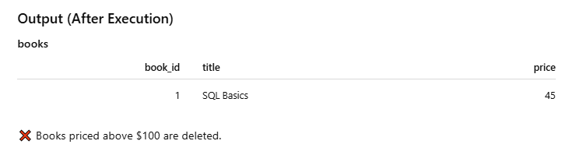

8. UPDATE Command LAB EXERCISES:
• Lab 3: Update the year_of_publication of a book with a specific book_id.
Input
book_id | title | year_of_publicon

101 | Clean Code | 2008

102 | Atomic Habits | 2018

Query
UPDATE books
SET year_of_publication = 2020
WHERE book_id = 101;


• Lab 4: Increase the price of all books published before 2015 by 10%.
Input (Table: books)
book_id | title | year_of_publication | price
1 | Book A | 2010 | 500
2 | Book B | 2016 | 400
3 | Book C | 2012 | 300

Query (SQL)
UPDATE books
SET price = price * 1.10
WHERE year_of_publication < 2015;
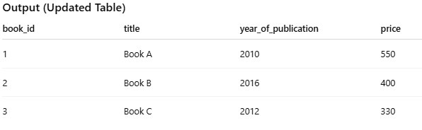

9. DELETE Command LAB EXERCISES:

• Lab 3: Remove all members who joined before 2020 from the members table.

Input (Table: members)
member_id | name | join_year
1 | Amit | 2018
2 | Neha | 2020
3 | Rahul | 2019
4 | Pooja | 2021

Query (SQL)
DELETE FROM members
WHERE join_year < 2020;

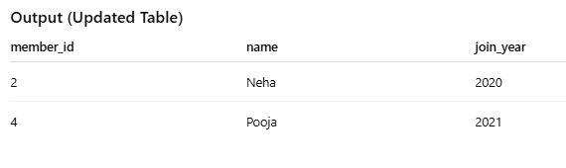

• Lab 4: Delete all books that have a NULL value in the author column.
Input (Table: books)
book_id | title | author | price
1 | Book A | John | 500
2 | Book B | NULL | 400
3 | Book C | Alice | 350
4 | Book D | NULL | 300
Query (SQL)
DELETE FROM books
WHERE author IS NULL;
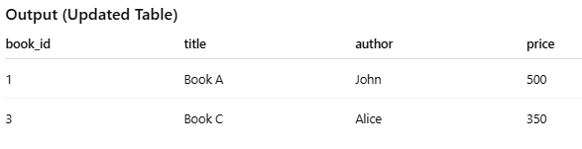

10. Data Query Language (DQL) LAB EXERCISES:
• Lab 4: Write a query to retrieve all books with price between $50 and $100.
Input (Table: books)
book_id | Title | author | price
1 | Book A | John | 45
2 | Book B | Alice | 60
3 | Book C | Mark | 80
4 | Book D | Sara | 100
5 | Book E | Tom | 120
Query (SQL)
SELECT *
FROM books
WHERE price BETWEEN 50 AND 100;
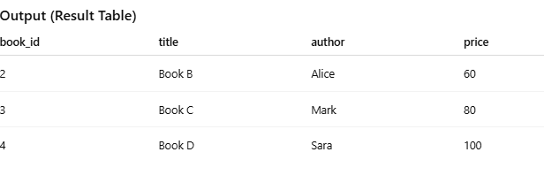

• Lab 5: Retrieve the list of books sorted by author in ascending order and limit the results to the top 3 entries.
book_id | title | author | price
1 | Book A | Mark | 60
2 | Book B | Alice | 80
3 | Book C | John | 55
4 | Book D | Bob | 70
5 | Book E | David | 90

Query (SQL)
SELECT *
FROM books
ORDER BY author ASC
LIMIT 3;
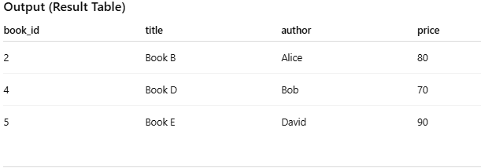

11. Data Control Language (DCL) LAB EXERCISES:

• Lab 3: Grant SELECT permission to a user named librarian on the books table.
Input
- User: librarian
- Table: books
- Permission: SELECT

Query
GRANT SELECT ON books TO librarian;
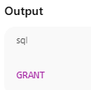

• Lab 4: Grant INSERT and UPDATE permissions to the user admin on the members table
Input
Table: members
member_id | name | Email | join_date
1 | Alice | alice@mail.com | 2024-01-01
2 | Bob | bob@mail.com | 2024-02-15
3 | Carol | carol@mail.com | 2024-03-10
User: admin
Action: Grant INSERT and UPDATE permissions
Query
GRANT INSERT, UPDATE ON members TO admin;
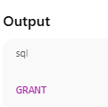
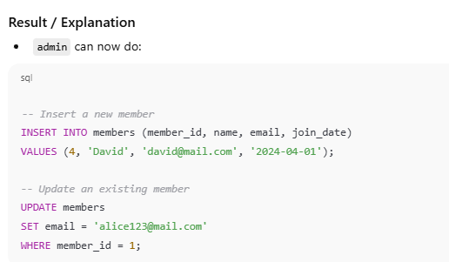
12. REVOKE Command LAB EXERCISES:
• Lab 3: Revoke the INSERT privilege from the user librarian on the books table.
Input
Table: books
book_id | Title | author | price
1 | Book A | John | 45
2 | Book B | Alice | 60
3 | Book C | Mark | 80
4 | Book D | Sara | 100
5 | Book E | Tom | 120
User: librarian
Action: Revoke INSERT privilege
Query
REVOKE INSERT ON books FROM librarian;
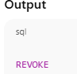

• Lab 4: Revoke all permissions from user admin on the members table.
Input
Table: members
member_id | name | email | join_date
1 | Alice | alice@mail.com | 2024-01-01
2 | Bob | bob@mail.com | 2024-02-15
3 | Carol | carol@mail.com | 2024-03-10
User: admin
Action: Revoke all permissions
Query
REVOKE ALL PRIVILEGES ON members FROM admin;
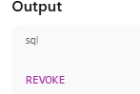

13. Transaction Control Language (TCL) LAB EXERCISES:
• Lab 3: Use COMMIT after inserting multiple records into the books table, then make another insertion and perform a ROLLBACK.
Input
Table: books
book_id | Title | author | price
1 | Book A | John | 45
2 | Book B | Alice | 60
3 | Book C | Mark | 80

Action:
- Insert multiple new records and COMMIT.
- Insert another record and ROLLBACK.

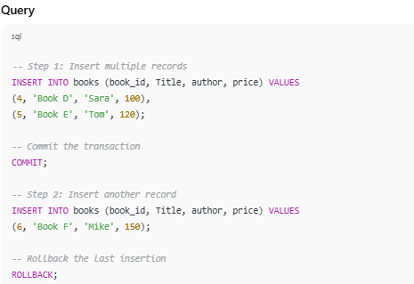
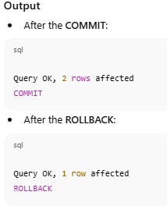

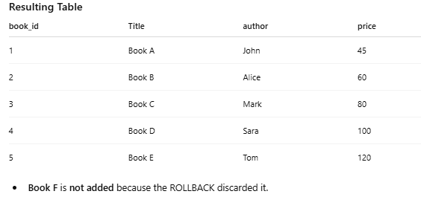

• Lab 4: Set a SAVEPOINT before making updates to the members table, perform some updates, and then roll back to the SAVEPOINT.
Input
Table: members
member_id | name | email | join_date
1 | Alice | alice@mail.com | 2024-01-01
2 | Bob | bob@mail.com | 2024-02-15
3 | Carol | Carol@mail.com | 2024-03-10
Action:
- Set a SAVEPOINT before updating.
- Perform updates.
- Roll back to the SAVEPOINT.
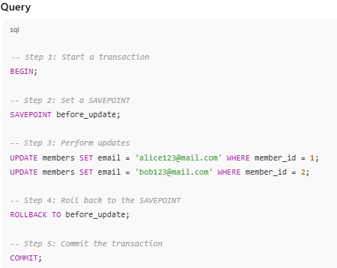
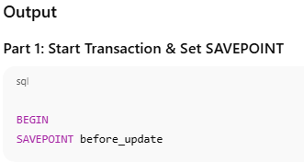
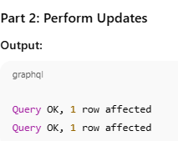
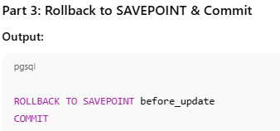

14. SQL Joins LAB EXERCISES:
• Lab 3: Perform an INNER JOIN between books and authors tables to display the title of books and their respective authors' names.
Input
Table: books
book_id | title | author_id | price
1 | Book A | 1 | 45
2 | Book B | 2 | 60
3 | Book C | 3 | 80
4 | Book D | 4 | 100
5 | Book E | 5 | 120
Table: authors
author_id | author_name
1 | John
2 | Alice
3 | Mark
4 | Sara
5 | Tom
Goal: Display book title and author name using INNER JOIN.
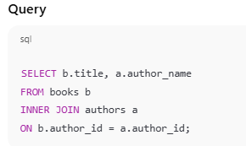
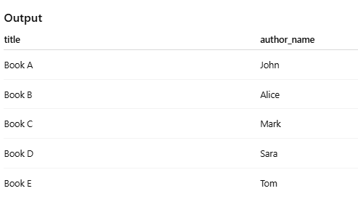

• Lab 4: Use a FULL OUTER JOIN to retrieve all records from the books and authors tables, including those with no matching entries in the other table.
Input
Table: books
book_id | title | author_id | price
1 | Book A | 1 | 45
2 | Book B | 2 | 60
3 | Book C | 3 | 80
4 | Book D | 6 | 100
Table: authors
author_id | author_name
1 | John
2 | Alice
3 | Mark
4 | Sara
5 | Tom
Note: Book D’s author_id = 6 does not exist in authors.
Author Sara (id=4) and Tom (id=5) exist in authors but have no books.
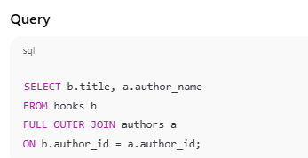
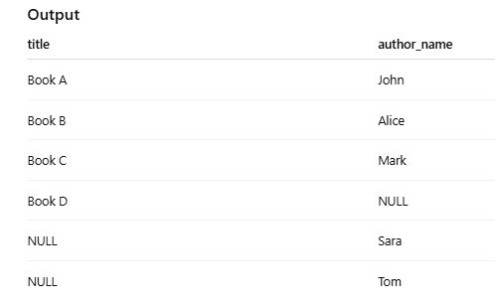

15. SQL Group By LAB EXERCISES:
• Lab 3: Group books by genre and display the total number of books in each genre.
Input
Table: books
book_id | title | genre | price
1 | Book A | Fiction | 45
2 | Book B | Fiction | 60
3 | Book C | Science | 80
4 | Book D | Fiction | 100
5 | Book E | Science | 120
Goal: Count total books in each genre.

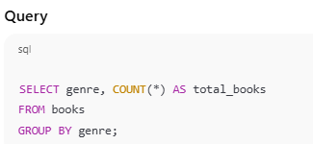

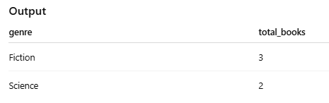

• Lab 4: Group members by the year they joined and find the number of members who joined each year.
Input
Table: members
member_id | name | email | join_date
1 | Alice | alice@mail.com | 2024-01-01
2 | Bob | bob@mail.com | 2024-02-15
3 | Carol | carol@mail.com | 2023-03-10
4 | David | david@mail.com | 2023-07-22
5 | Eva | E va@mail.com | 2024-05-05
Goal: Count members per joining year.
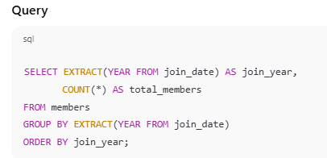
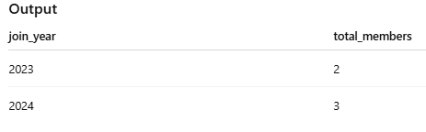

16. SQL Stored Procedure LAB EXERCISES:
• Lab 3: Write a stored procedure to retrieve all books by a particular author.
Input
Author name provided by the user:
J.K. Rowling
Query (Stored Procedure)
CREATE PROCEDURE GetBooksByAuthor
@AuthorName NVARCHAR(100)
AS
BEGIN
SELECT BookID, Title, Author, PublishedYear
FROM Books
WHERE Author = @AuthorName;
END;
Execution:
EXEC GetBooksByAuthor 'J.K. Rowling';
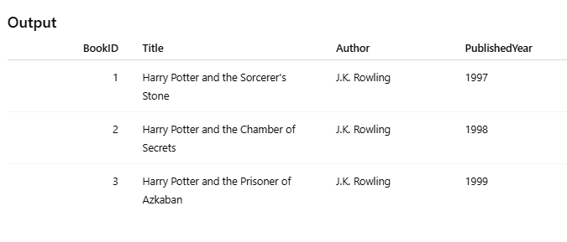

• Lab 4: Write a stored procedure that takes book_id as an argument and returns the price of the book
Input
- book_id (INTEGER)

Query (Stored Procedure)
Assume table: books(book_id, price)
DELIMITER //

CREATE PROCEDURE GetBookPrice (
IN p_book_id INT
)
BEGIN
SELECT price
FROM books
WHERE book_id = p_book_id;
END //

DELIMITER ;

How to Execute
CALL GetBookPrice(101);
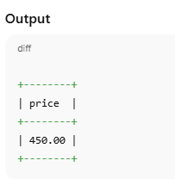

17. SQL View LAB EXERCISES:
• Lab 3: Create a view to show only the title, author, and price of books from the books table.

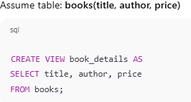

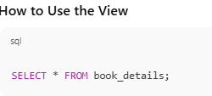

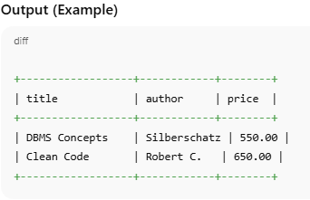

• Lab 4: Create a view to display members who joined before 2020.
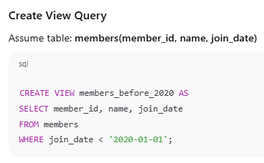

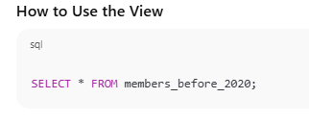

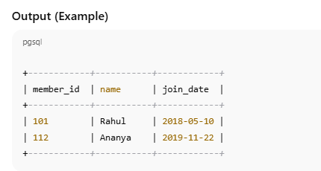

18. SQL Trigger LAB EXERCISES:
• Lab 3: Create a trigger to automatically update the last_modified timestamp of the books table whenever a record is updated.
Input
- Update operation on books table
Example input values:
- book_id = 101
- New price = 500
Queries
Trigger Creation
DELIMITER //
CREATE TRIGGER update_books_last_modified
BEFORE UPDATE ON books
FOR EACH ROW
BEGIN
SET NEW.last_modified = CURRENT_TIMESTAMP;
END //
DELIMITER ;
Update Query (Input Action)
UPDATE books
SET price = 500
WHERE book_id = 101;
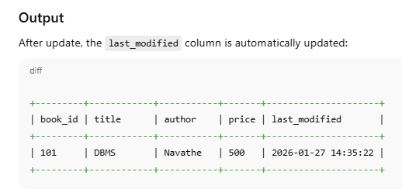

• Lab 4: Create a trigger that inserts a log entry into a log_changes table whenever a DELETE operation is performed on the books table.
Input
- A DELETE operation performed on the books table
- Example: deleting book_id = 101
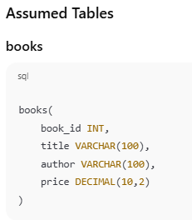
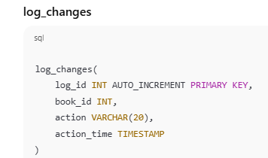
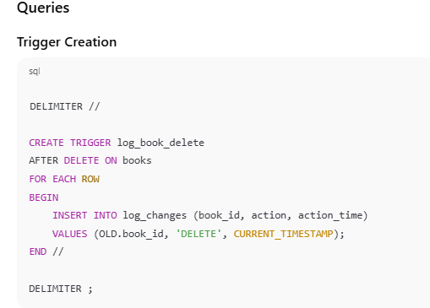
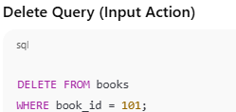

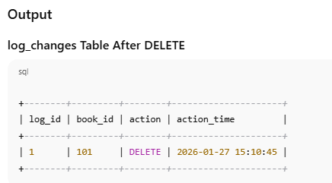

19. Introduction to PL/SQL LAB EXERCISES:
• Lab 3: Write a PL/SQL block to insert a new book into the books table and display a confirmation message.
Assume table: books(book_id, title, author, price)
BEGIN
INSERT INTO books (book_id, title, author, price)
VALUES (201, 'DBMS Basics', 'Korth', 450);

DBMS_OUTPUT.PUT_LINE('Book inserted successfully');
END;
/

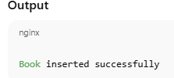

• Lab 4: Write a PL/SQL block to display the total number of books in the books table.
PL/SQL Block
DECLARE
total_books NUMBER;
BEGIN
SELECT COUNT(*)
INTO total_books
FROM books;
DBMS_OUTPUT.PUT_LINE('Total number of books: ' || total_books);
END;
/
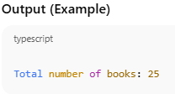

20. PL/SQL Syntax LAB EXERCISES:
• Lab 3: Write a PL/SQL block to declare variables for book_id and price, assign values, and display the results.
PL/SQL Block
DECLARE
v_book_id NUMBER := 101;
v_price NUMBER := 550;
BEGIN
DBMS_OUTPUT.PUT_LINE('Book ID: ' || v_book_id);
DBMS_OUTPUT.PUT_LINE('Price: ' || v_price);
END;
/
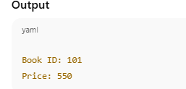

• Lab 4: Write a PL/SQL block using constants and perform arithmetic operations on book prices.
PL/SQL Block
DECLARE
base_price CONSTANT NUMBER := 500;
discount_rate CONSTANT NUMBER := 0.10; -- 10% discount
final_price NUMBER;
BEGIN
final_price := base_price - (base_price * discount_rate);
DBMS_OUTPUT.PUT_LINE('Base Price: ' || base_price);
DBMS_OUTPUT.PUT_LINE('Discount Rate: ' || (discount_rate * 100) || '%');
DBMS_OUTPUT.PUT_LINE('Final Price after Discount: ' || final_price);
END;
/
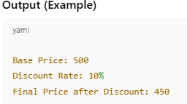

21. PL/SQL Control Structures LAB EXERCISES:
• Lab 3: Write a PL/SQL block using IF-THEN-ELSE to check if a book's price is above $100 and print a message accordingly.
PL/SQL Block
DECLARE
v_price NUMBER := 150;
BEGIN
IF v_price > 100 THEN
DBMS_OUTPUT.PUT_LINE('The book price is above $100');
ELSE
DBMS_OUTPUT.PUT_LINE('The book price is $100 or below');
END IF;
END;
/
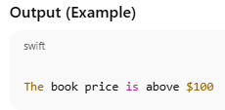
• Lab 4: Use a FOR LOOP in PL/SQL to display the details of all books one by one.
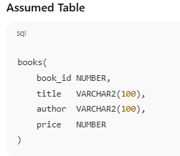
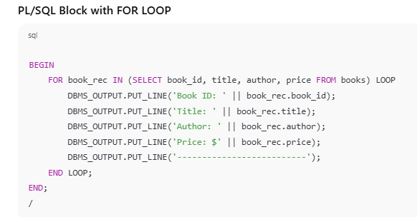
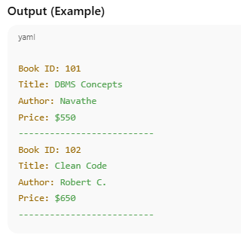

22. SQL Cursors LAB EXERCISES:
• Lab 3: Write a PL/SQL block using an explicit cursor to fetch and display all records from the members table.
Input
- members table contains the following records:
member_id | name | join_date
101 | Rahul | 2018-05-10
112 | Ananya | 2019-11-22
120 | Sameer | 2021-03-15

PL/SQL Block with Explicit Cursor
DECLARE
-- Step 1: Declare the cursor
CURSOR members_cur IS
SELECT member_id, name, join_date
FROM members;
-- Step 2: Declare a record variable to hold cursor row
member_rec members_cur%ROWTYPE;
BEGIN
-- Step 3: Open the cursor
OPEN members_cur;
-- Step 4: Fetch each row and display
LOOP
FETCH members_cur INTO member_rec;
EXIT WHEN members_cur%NOTFOUND;

DBMS_OUTPUT.PUT_LINE('Member ID: ' || member_rec.member_id);
DBMS_OUTPUT.PUT_LINE('Name: ' || member_rec.name);
DBMS_OUTPUT.PUT_LINE('Join Date: ' || TO_CHAR(member_rec.join_date, 'YYYY-MM-DD'));
DBMS_OUTPUT.PUT_LINE('-------------------------');
END LOOP;
-- Step 5: Close the cursor
CLOSE members_cur;
END;
/
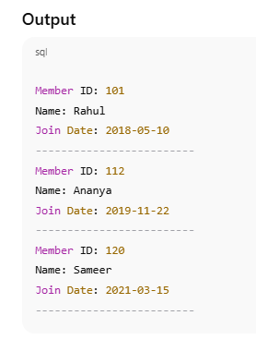

• Lab 4: Create a cursor to retrieve books by a particular author and display their titles.
Input
- Author name to search: 'Robert C.'
- books table contains:
book_id | title | author | price
101 | Clean Code | Robert C. | 650
102 | Agile Principles | Robert C. | 700
103 | DBMS Concepts | Navathe | 550
Queries (PL/SQL Block)
DECLARE
-- Input author
v_author_name VARCHAR2(100) := 'Robert C.';
-- Declare cursor
CURSOR books_by_author_cur IS
SELECT title
FROM books
WHERE author = v_author_name;
-- Record variable
book_rec books_by_author_cur%ROWTYPE;
BEGIN
-- Open cursor
OPEN books_by_author_cur;
-- Loop through each book
LOOP
FETCH books_by_author_cur INTO book_rec;
EXIT WHEN books_by_author_cur%NOTFOUND;
DBMS_OUTPUT.PUT_LINE('Book Title: ' || book_rec.title);
END LOOP;
-- Close cursor
CLOSE books_by_author_cur;
END;

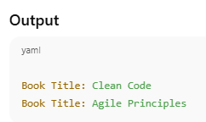

23. Rollback and Commit Savepoint LAB EXERCISES:
• Lab 3: Perform a transaction that includes inserting a new member, setting a SAVEPOINT, and rolling back to the savepoint after making updates.
Input
- members table contains:
member_id | name | join_date
101 | Rahul | 2018-05-10
112 | Ananya | 2019-11-22
- Action:
  - Insert a new member: member_id = 130, name = Sakshi, join_date = 2026-01-27
  - Update her name to Sakshi Sharma
  - Rollback to savepoint to undo the update
BEGIN
-- Step 1: Insert a new member
INSERT INTO members (member_id, name, join_date)
VALUES (130, 'Sakshi', TO_DATE('2026-01-27', 'YYYY-MM-DD'));
DBMS_OUTPUT.PUT_LINE('New member inserted.');
-- Step 2: Set a SAVEPOINT
SAVEPOINT before_update;
-- Step 3: Update member name
UPDATE members
SET name = 'Sakshi Sharma'
WHERE member_id = 130;
DBMS_OUTPUT.PUT_LINE('Member name updated.');
-- Step 4: Rollback to the SAVEPOINT
ROLLBACK TO before_update;
DBMS_OUTPUT.PUT_LINE('Rolled back to SAVEPOINT. Update undone, insert retained.');
-- Step 5: Commit the transaction
COMMIT;
DBMS_OUTPUT.PUT_LINE('Transaction committed.');
END;
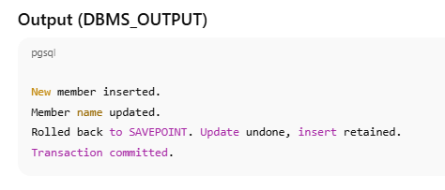
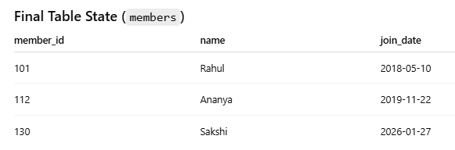

• Lab 4: Use COMMIT after successfully inserting multiple books into the books table, then use ROLLBACK to undo a set of changes made after a savepoint.
Input
- books table initially contains:
book_id | title | author | price
101 | DBMS | Navathe | 550
102 | Clean Code | Robert C. | 650
- Actions:
  - Insert 3 new books:
    - 201, DBMS Basics, Korth, 450
    - 202, Clean Code, Robert C., 650
    - 203, Algorithms, Cormen, 700
  - Commit the insertions
  - Set a SAVEPOINT
  - Update prices of book_id 201 and 202 by +50
  - Rollback to the SAVEPOINT

Queries (PL/SQL Block)
BEGIN
-- Step 1: Insert multiple books
INSERT INTO books (book_id, title, author, price)
VALUES (201, 'DBMS Basics', 'Korth', 450);
INSERT INTO books (book_id, title, author, price)
VALUES (202, 'clean Code', 'Robert C.', 650);
INSERT INTO books (book_id, title, author, price)
VALUES (203, 'Algorithms', 'Cormen', 700);
-- Step 2: Commit the inserted books
COMMIT;
DBMS_OUTPUT.PUT_LINE('Multiple books inserted and committed.');
-- Step 3: Set a SAVEPOINT
SAVEPOINT after_commit;
-- Step 4: Make changes that we might want to undo
UPDATE books
SET price = price + 50
WHERE book_id IN (201, 202);
DBMS_OUTPUT.PUT_LINE('Prices updated for some books.');
-- Step 5: Rollback to the SAVEPOINT
ROLLBACK TO after_commit;
DBMS_OUTPUT.PUT_LINE('Rolled back to savepoint. Price updates undone.');
END
